AyurSense: An Intelligent Ayurvedic Recommendation System
Project Report
Submitted in Partial Fulfillment of the Requirements for the Degree of
BACHELOR OF TECHNOLOGY
in
COMPUTER SCIENCE & ENGINEERING

By
Manya Thapliyal (2200950100048)
Prashant Bisht (2200950100059)

Under the Guidance of Mrs. Roovi Goswami



DEPARTMENT OF COMPUTER SCIENCE & ENGINEERING
MGM’s College of Engineering & Technology, Noida

TABLE OF CONTENTS

- CERTIFICATE ............................................................................................................... 4
- DECLARATION .............................................................................................................5
- ABSTRACT .................................................................................................................... 6
- CHAPTER 1: INTRODUCTION ............................................................................ 7-15
  - Background of Ayurveda & Dosha Theory
  - Understanding Vata, Pitta, Kapha
  - Problem Statement
  - Motivation for the Project
  - Objectives of the Project
  - Scope of the Project
  - Overview of AyurSense Platform
  - Significance of the Project
- CHAPTER 2: LITERATURE REVIEW.................................................................16-19
2.1 Research on Ayurveda & Prakriti Assessment
2.2 Existing System
2.3 Comparison & Gap Analysis
2.4 Key Findings
- CHAPTER 3: SYSTEM ANALYSIS.......................................................................20-27
3.1 Introduction
3.2 Existing System
3.3 Problems in Existing System
3.4 Proposed AyurSense System
3.5 Feasibility Study
3.6 Requirement Analysis
3.7 System Requirements
- CHAPTER 4: SYSTEM DESIGN..........................................…………………….28-36
4.1 System Architecture
4.2 Data Flow Diagrams
4.3 Use Case Diagram
4.4 ER Diagram
4.5 Class Diagram
4.6 UI/UX Wireframes
4.7 Data Model
- CHAPTER 5: IMPLEMENTATION.................................................................... 37-47
5.1 Tech Stack Used
5.2 Module Implementation
5.3 Screenshots of Implemented Modules
- CHAPTER 6: TESTING & EVALUATION........................................................ 48-52
6.1 Testing Strategy
6.2 Unit Testing
6.3 Integration Testing
6.4 Functional Testing
6.5 Test Cases & Results
6.6 Sample Outputs
- CHAPTER 7: RESULTS & DISCUSSION.......................................................... 53-56
  - System Output Summary
  - Dosha Assessment Results
  - Evaluation of Accuracy
  - User Observations
  - Discussion
- CHAPTER 8: CONCLUSION & FUTURE WORK........................................... 57-60
8.1 Conclusion
8.2 Achievements
8.3 Limitations
8.4 Future Enhancements
8.5 Final Thoughts
- REFERENCES.............................................................................................................61
- PRPJECT DRILL REPORT………………………………………………………...62
- RESEARCH PAPER……………………………………………………………...63-71
- RESEARCH PAPER DRILL REPORT…………………………………………….72

CERTIFICATE

This is to certify that Project Report entitled “AyurSense: An Intelligent Ayurvedic Recommendation System ” which is submitted by Manya Thapliyal and Prashant Bisht in partial fulfillment of the requirement for the award of degree B. Tech. in Department of Computer Science and Engineering of MGM’s College of Engineering and Technology which is affiliated by AKTU Lucknow, is a record of the candidates own work carried out by them under my supervision. The matter embodied in this report is original and has not been submitted for the award of any other degree.

Date: 20-11-2025 Supervisor Signature:
Name of Supervisor: Mrs. Roovi Goswami
Designation: Assistant Professor

DECLARATION

I hereby declare that this submission is our own work and that, to the best of our knowledge and belief, it contains no material previously published or written by another person nor material which to a substantial extent has been accepted for the award of any other degree or diploma of the university or other institute of higher learning, except where due acknowledgment has been made in the text.

Signature:
Name: Manya Thapliyal
Roll No.: 2200950100048
Date: 20-11-2025

Signature:
Name: Prashant Bisht
Roll No.: 2200950100059
Date: 20-11-2025

ABSTRACT

A web-based program called AyurSense: Intelligent Ayurvedic Recommendation System was created to offer individualized Ayurvedic treatments, yoga poses, and lifestyle recommendations depending on user inputs. After evaluating symptoms and medical issues using an interactive quiz, the program maps the results to a pre-established database of Ayurvedic remedies and wellness techniques to produce suggestions.
The primary goal of this project is to develop a user-friendly system that promotes natural and preventative healthcare practices while allowing people to get advice for minor health issues without the requirement for an instant consultation with a medical professional. The system design consists of a database management system for symptoms, treatments, and yoga poses, as well as a questionnaire interface and recommendation engine.

In order to ensure responsiveness and real-time user interaction, AyurSense is built with frontend and backend integration using contemporary web technologies. OCR-based symptom scanning, AI/ML-based tailored recommendations, and user history monitoring for more precise assistance are possible future improvements.
This study shows how technology and traditional Ayurvedic knowledge may be combined to effectively and interactively give easily available health treatments.

CHAPTER 1: INTRODUCTION

1.1 Background of Ayurveda & Dosha Theory
The traditional Indian medical practice known as Ayurveda is among the earliest holistic healing systems ever discovered. Ayurveda, which dates back more than 3000 years, offers a thorough understanding of human physiology, psychology, lifestyle, and illness prevention. The term "Ayurveda" refers to "the science of life" and is derived from two Sanskrit words: Ayur (life) and Veda (knowledge or science). Ayurveda places more emphasis on preserving equilibrium, avoiding illnesses, and comprehending the person as a whole than contemporary medical methods, which are mainly concerned with treating symptoms. In accordance with nature, it acknowledges the human being as a synthesis of body, mind, and spirit.
Ayurveda is built on ancient texts, primarily the Charaka Samhita, Sushruta Samhita, and Ashtanga Hridayam. These scriptures describe the structure of the body, diagnosis, treatment methods, herbal formulations, mental health principles, and lifestyle guidelines. A distinctive feature of Ayurveda is its personalized approach. It believes that every person is unique and therefore requires personalized care rather than generalized treatment. This individuality arises from the unique constitution, known as Prakriti, established at birth.
The ratio of the three doshas that control every bodily function—Pitta, Kapha, and Vata—determines Prakriti. Earth, water, fire, air, and space are the five elements (Panchamahabhutas) that make up these doshas. They control everything, including circulation, digestion, emotions, and sleep habits. According to Ayurveda, health arises when the doshas are balanced. Diseases arise when the doshas are out of balance as a result of poor eating habits, lifestyle decisions, stress, or environmental factors. Ayurveda's central tenet is the restoration of balance through nutrition, lifestyle control, herbal medicines, and mental discipline.
Ayurvedic diagnosis and therapy are therefore based on the Dosha Theory. Practitioners are able to recognize patterns, vulnerabilities, and possible long-term hazards by knowing a person's dosha composition. Because of the growing prevalence of lifestyle problems, stress, and the demand for natural therapy, Ayurveda and dosha assessment have become increasingly important in the modern era. People are looking for preventive and holistic healthcare systems due to urbanization, poor eating habits, sedentary routines, and digital stress.
This age-old knowledge serves as the model for the AyurSense project. By automating the dosha assessment procedure, Ayurveda is made more accessible, convenient, and technologically advanced. Users can use a systematic questionnaire to study their dosha and instantly receive individualized insights, rather than depending just on manual assessment or going to a practitioner. This is in line with the global trend toward preventive wellness and customized digital health.

1.2 Understanding Vata, Pitta, Kapha
According to Ayurveda, the body is controlled by three doshas, or fundamental biological energies. The Panchamahabhutas (five elements) are the source of these doshas, which characterize mental, emotional, and physical traits. Each person's Prakriti (constitution) is formed by the distinct combination of these doshas that they possess at birth. Comprehending doshas is crucial for self-awareness, good lifestyle choices, and identifying imbalances before they develop into illnesses.
1. Vata Dosha (Air + Space)
All bodily motion is controlled by vata, which is the symbol for movement. Breathing, blinking, heart rate, nerve impulses, circulation, and waste removal are all regulated by it. It is in charge of imagination, inventiveness, and fast thinking.
Characteristics of Vata Individuals:
- Body: Light, lean, dry skin, chilly hands and feet.
- Mind: Imaginative, expressive, quick to pick things up, but also prone to forgetfulness.
- Emotion: Exuberant but prone to anxiety and terror.
- Physiology: Irregular sleep habits and digestion.
Imbalance Symptoms: Anxiety, sleeplessness, dryness, constipation, joint discomfort, and restlessness are some of the symptoms.
2. Pitta Dosha (Fire + Water)
Digestion and transformation are governed by pitta. It regulates hormones, metabolism, body temperature, eyesight, and mental processes.
Characteristics of Pitta Individuals:
- Body: Warm body temperature; medium build.
- Mind: Intelligent, disciplined, and capable of making sound decisions.
- Emotion: Self-assured, competitive, but easily enraged.
- Physiology: robust digestion and hunger.
Imbalance Symptoms: Rashes, inflammation, acidity, irritation, and extreme heat.
3. Kapha Dosha (Earth + Water)
Kapha is in charge of stability, structure, and lubrication. It preserves immunity, physical strength, and emotional serenity.
Characteristics of Kapha Individuals:
- Body: Smooth/oily skin, robust bones, and a heavier build.
- Mind: composed, patient, and stable.
- Emotion: faithful, stable, and compassionate.
- Physiology: Consistent but gradual digesting.
Imbalance Symptoms: Weight gain, congestion, lethargy, sadness, and excessive sleeping are among the symptoms.
The basis for comprehending one's personality and health is formed by these doshas taken together. AyurSense assesses these characteristics in order to determine the prevalent dosha and assist users in leading balanced lives.

1.3 Problem Statement
Stress, erratic sleep patterns, poor diet, inactivity, and mental instability are just a few of the major lifestyle-related health issues that people face today. Even if preventative healthcare is becoming more widely known, people frequently do not comprehend the underlying causes of their physical and mental disorders. With its all-encompassing approach to wellbeing, Ayurveda offers insightful information by determining a person's Prakriti (body constitution) and comprehending how lifestyle decisions affect health. However, traditional Ayurvedic evaluation takes a lot of time, needs skilled practitioners, and is difficult for the general public—especially young people and busy professionals—to access.
Furthermore, the majority of people are unable to make lifestyle decisions that are consistent with their innate constitution because they are unaware of their dominant dosha, which can be either Vata, Pitta, or Kapha. Although Ayurveda is becoming more and more popular worldwide, there are currently few digitized, organized, and easy-to-use assessment tools available. Current internet tools lack individualized recommendations based on thorough inputs, are too short, or are medically erroneous. Due to this gap, there is a great demand for a trustworthy digital platform that makes dosha assessment easier and offers insightful, useful information.
The incompatibility of contemporary digital technologies and traditional Ayurvedic ideas is another issue. The digital wellness sector has primarily concentrated on calorie monitoring, activity tracking, and mental health, leaving a lack in Ayurvedic-driven data despite the increased desire for tailored health recommendations. A systematic digital solution that assesses the habits, physical characteristics, emotional inclinations, and lifestyle elements of young people, students, and working adults is needed to make Ayurveda more accessible to them.
Thus, the project's goal is to create a digital platform that uses a scientifically structured questionnaire to analyze a person's dosha constitution and offers tailored Ayurvedic lifestyle recommendations, making self-health awareness approachable and simple to comprehend.

1.4 Motivation for the Project
The growing demand for easily available wellness solutions that emphasize customization over general guidance is what inspired the creation of AyurSense. People frequently find it difficult to comprehend their natural physical constitution and how it affects day-to-day living due to increased stress, poor behaviors, and an excessive reliance on fast-paced lifestyles. Ayurveda offers profound insights into self-awareness and preventive treatment as a tried-and-true health and wellness method. However, a lack of accessibility, understanding, and useful digital tools frequently results in the underutilization of this knowledge.
The goal of bridging the knowledge gap between ancient and current technologies is one of the main drivers. Although Ayurveda provides helpful assistance, there aren't many digital solutions that make dosha assessment systematic and understandable. This led to the development of a system that allows users to become self-aware in a matter of minutes without the need for prior medical knowledge or expert consultations.
Second, systems that customize recommendations based on distinct individual characteristics are encouraged by the growing global trend toward customized wellness. Yoga, mindfulness, herbal cures, holistic healing, and natural lifestyles are becoming more popular among people. This change is well suited to a platform like AyurSense, which uses dosha theory to help people understand their bodies and emotions.
Students, working professionals, and homemakers frequently experience anxiety, digestive problems, exhaustion, and emotional imbalance without knowing the underlying cause, which is another source of inspiration. Giving them a straightforward way to determine their dominant dosha and receive preventive advice will greatly enhance daily routines and general health.
Lastly, developing AyurSense provides a chance for a technology student to use their knowledge of web development, UX design, logic-building, and system analysis to a practical issue. This inspires the development of a technically demanding, socially relevant, and meaningful initiative that promotes digital wellness.

1.5 Objectives of the Project
The goal of the AyurSense project is to create a bridge between technology and Ayurveda. Its goals are in line with producing precise results, offering practical advice, and enhancing user experience.The primary and secondary objectives are listed below:
Primary Objectives
- To develop a digital dosha testing tool using an Ayurvedic-inspired structured questionnaire.
- To employ a logic-based scoring method to identify the user's dominant dosha (Pitta, Kapha, or Vata).
- To offer tailored advice on nutrition, habits, lifestyle, mindfulness, and overall health.
- To facilitate self-awareness by assisting users in comprehending the constitution of their bodies (Prakriti).
Secondary Objectives
1. Create a user-friendly interface that makes it simple for users to traverse the system and respond to inquiries.
2. Develop a scoring and assessment model that precisely associates user responses with dosha traits.
3. Make sure the platform is usable by new users without requiring a login.
4. Present results in an eye-catching manner to enhance user comprehension.
5. Encourage people to lead healthier lifestyles in order to advance preventative healthcare.
6. Connect traditional Ayurvedic ideas with contemporary digital wellness to make age-old science applicable to the present day.
The goals guarantee that AyurSense serves as an educational resource for consumers looking for natural, individualized wellness advice in addition to being an assessment tool.

1.6 Scope of the Project
The AyurSense project's characteristics, capabilities, and constraints are described in its scope. What the system will and won't cover is made very plain.
In-Scope Features
1. Questionnaire for Doha Assessment:
a set of questions about physical characteristics, digestion, emotions, lifestyle choices, and behavioral tendencies.
2. Logic-Based Scoring Engine:
In order to identify the prevalent dosha, each response adds points toward Vata, Pitta, or Kapha.
3. User-Friendly Interface:
The platform's clear user interface makes it easy for users to finish the examination.
4. Results Interpretation:
A thorough description of the user's dominant dosha, traits, and inclinations.
5. General Ayurvedic Advice:
Dietary, lifestyle, sleep, habit, and balancing regimen recommendations.
6. Instant Report Generation:
After submitting answers, users get the findings right away.
Out of Scope
- Medical diagnosis or recommended course of therapy
- Prescription of medications or cutting-edge treatments
- Consultation with Ayurvedic physicians
- Forecast of diseases
- Sophisticated AI models that merely use fundamental logic
- Medical intervention is not the system's primary goal; instead, it is wellness guidance.

1.7 Overview of AyurSense Platform
AyurSense is a cutting-edge web-based tool created to make Ayurvedic dosha evaluation quick, easy, and comprehensible. It converts traditional Ayurvedic concepts into a digital survey that assesses an individual's prevailing dosha and offers fundamental advice for preserving equilibrium. To assist users in comprehending their inherent constitution, the platform integrates interactive user interface, logic-based computing, and instructional content.
Key Functional Components
- User Interface Module
  - Simple and engaging design
  - Physical, emotional, and lifestyle-related questions
- Assessment Engine
  - The Vata, Pitta, or Kapha scores are increased by each response
  - The algorithm finds combinations of dominant doshas or dual doshas
- Result Generation Module
  - The final dosha score is displayed
  - Describes the features
  - Emphasizes advantages and disadvantages
- Recommendation Engine
  - Suggested foods to be balanced
  - Provides advice on lifestyle
  - Recommends rituals and habits
- Frontend Technologies
HTML, CSS, JavaScript, and Flask/Python were used in its construction to ensure seamless performance and simple deployment.
Traditional Ayurveda is transformed by AyurSense into a straightforward digital health tool that is appropriate for students and contemporary consumers.

1.8 Significance of the Project
The AyurSense project is highly relevant in the modern world because of the growing interest in holistic therapy, preventive healthcare, and individualized wellness. Maintaining one's bodily and mental well-being requires an understanding of one's inherent constitution as lifestyle disorders become more common.
Key Significances
1. Promotes Self-Awareness
Making healthier lifestyle choices is facilitated by users' understanding of their body type, mental tendencies, strengths, and weaknesses.
2. Encourages Preventive Health
AyurSense assists users in identifying imbalances early on and taking corrective action, as opposed to treating illnesses after they arise.
3. Brings Ayurveda to the Digital World
AyurSense updates traditional information and makes it available to youth, working adults, and students.
4. Enhances Personal Wellness
Users' digestion, sleep, emotional equilibrium, immunity, and productivity are all enhanced by personalized recommendations.
5. Easy Accessibility
Users can access quick analysis from any location, without the need for a login or medical background.
6. Supports Academic & Research Understanding
The project shows how theoretical knowledge (HTML, CSS, JS, Flask, logic construction) can be used practically to a socially significant field.
7. Contributes to Mental Well-Being
Dosha balance improves general wellbeing, lowers stress, and promotes emotional stability.
All things considered, AyurSense is a useful health tool that combines technology, tradition, and science to produce an approachable self-assessment platform.

CHAPTER 2: LITERATURE REVIEW

2.1 Research on Ayurveda & Prakriti Assessment
One of the first holistic medical systems in the world, Ayurveda, places a strong emphasis on individualized well-being based on the idea of Prakriti (specific body constitution). Every human person has a distinct physical and psychological constitution that is created at birth by the combination of the three basic bio-energies known as Doshas—Vata, Pitta, and Kapha—according to traditional Ayurvedic writings like Charaka Samhita and Sushruta Samhita. A person's metabolism, immunity, emotional inclinations, food compatibility, and susceptibility to illness are all influenced by these doshas.
Because of its applicability in precision, preventative, and predictive medicine, Prakriti-based customized healthcare has attracted more attention from scientists in recent years. Studies have revealed associations between Prakriti categories and physiological, biochemical, and genetic characteristics, suggesting its possible application in contemporary medical profiling. Prakriti assessment employing questionnaires, biometric inputs, and behavioural characteristics is becoming automated and standardized through the use of digital health platforms and machine-learning algorithms.
Prakriti assessment is essential for web-based solutions such as AyurSense since it serves as the foundation for individualized suggestions that include nutrition, lifestyle, yoga, meditation, and herbal medicines. By assisting people in understanding their innate tendencies and taking proactive measures to control their health, digital Prakriti analysis tools also improve user engagement, lessen reliance on in-person consultations, and promote preventive wellness. Prakriti-based health assessment is a solid basis for customized wellness technology platforms since it integrates ancient Ayurvedic knowledge with contemporary digital interfaces.

2.2 Existing System
There are a number of platforms available in the contemporary digital healthcare and wellness sector that give Ayurvedic-based advice, consultations, and health improvement plans. However, rather than offering a completely customized, data-driven Prakriti-based lifestyle and health recommendation model, the majority of current systems primarily concentrate on generic Ayurvedic knowledge, online medical consultations, or product sales. Without deeply integrating user-specific analytics like habits, symptoms, diet, and emotional patterns, many platforms rely on conventional questionnaire-based assessment. Furthermore, long-term involvement and precise prevention-oriented therapy are limited because the majority of users do not receive ongoing monitoring or dynamic updates based on evolving health situations.

Key Features in Existing Systems
- Offer blogs, Ayurvedic treatments, informational materials, and basic advice.
- Provide online voice and video consultations with qualified Ayurvedic practitioners.
- Make Ayurvedic medications, vitamins, oils, and herbs available online.
- Using static questionnaires, administer simple Prakriti or Dosha tests.
- Give basic advice on yoga, meditation, diet, and lifestyle balancing.

Limitations of Existing Systems
- Limited customisation based only on quiz answers, not on continuous health data.
- The absence of habit monitoring or real-time tracking to improve suggestions.
- Yoga poses, food programs, and herbal advice are not automatically integrated.
- Very no wellness trend analysis or AI-based prediction.
- A lot of platforms are less concerned with user-centric wellbeing and more with business (product sales).
- The lack of intuitive dashboards for motivation and progress visualization.

2.3 Comparison & Gap Analysis
There is still a significant gap between completely automated, individualized digital wellness support and conventional Ayurvedic evaluation methods, despite the fact that a number of digital healthcare platforms presently offer Ayurvedic knowledge, consulting services, or general wellness guidance. Rather than offering ongoing, personalized recommendations based on a person's Prakriti, symptoms, and daily living choices, the majority of platforms concentrate more on offering information or selling goods. AyurSense, on the other hand, attempts to close this gap by combining Ayurveda, yoga, and diet-based wellness planning on a single digital platform through the integration of intelligent assessment tools, user-specific statistics, and holistic suggestion modules.

Comparative Factors

Parameter | Existing Platforms | AyurSense (Proposed)
Nature of Guidance | Mostly generalized | Fully personalized
Assessment Method | Basic or static quizzes | Dynamic & multi-factor analysis
Focus Area | Info/blogs, consultation, product selling | Preventive & lifestyle-driven care
Recommendation Type | Limited or generic | Ayurveda + Yoga + Diet combined
User Monitoring | Minimal | Continuous & profile-based
Accessibility | Mixed & sometimes complex | Simple, youth-friendly, digital platform

Identified Gaps
- Data-driven personalization and habit-based recommendation modifications are absent.
- Inadequate integration of yoga, Ayurveda, and nutrition planning into one system.
- Treatment or product sales are the main focus, with little attention paid to preventive wellbeing.
- There is no cycle of ongoing user monitoring or improvement.
- A digital tool that is easier to use is necessary to draw in younger, tech-savvy users.

2.4 Key Findings
A number of significant insights have been found based on the examination of current literature, digital wellness platforms, and Ayurvedic assessment techniques. Ayurveda emphasizes the importance of Prakriti in defining a person's physical, mental, and emotional traits, which makes it a solid foundation for individualized medical care. Additionally, research indicates that digital technology can improve awareness and accessibility; yet, the majority of existing platforms lack comprehensive Ayurvedic practice integration and deep customisation. Building a systematic, intelligent, and user-focused platform that integrates conventional wisdom with cutting-edge digital technologies to direct users toward preventive and long-term wellness is obviously possible.

Major Findings
- Personalized Ayurvedic healthcare is based on Prakriti-based assessment, which suggests that individual wellness suggestions should vary.
- Instead of providing customized lifestyle advice, current digital platforms concentrate on delivering products, consultations, or generic material.
- Adaptive suggestions, symptom-based mapping, and data analytics are not widely used in Ayurvedic applications today.
- Users, particularly young people and those looking for wellness for the first time, want user-friendly, graphically clear, and mobile-friendly sites.
- Currently, most remedies lack a holistic strategy that incorporates Ayurveda, yoga, food, and routine management.
- The use of digital awareness tools for preventive healthcare is growing, suggesting that platforms such as AyurSense have great promise.

CHAPTER 3: SYSTEM ANALYSIS

3.1 Introduction
System design is a critical stage in the software development process where the proposed system's general architecture, components, and data flow are planned. It serves as a blueprint that describes how the system will function, how different modules will work together, and how user needs will be translated into a useful piece of software. Ensuring that the final implementation is effective, scalable, user-friendly, secure, and able to fulfill all stated project goals is the primary goal of system design.
The AyurSense platform's system design is crucial in determining how user inputs, Prakriti assessment data, and health-related information will be processed to produce customized dietary, yoga, and Ayurvedic recommendations. Additionally, it concentrates on creating interactive user interfaces, upholding safe user profiles, organizing the information, and developing the recommendation engine's logic. This chapter contains database structure, component interactions, data flow diagrams, and architectural design, all of which together specify how the system will be constructed and run.

3.2 Existing System

A number of venues in the current digital wellness landscape provide Ayurvedic consultations, online health literature, and simple self-assessment tests. Nevertheless, the majority of these systems have limitations in terms of capability, design, and customization. The current systems prioritize product-based solutions or static information distribution over user-centric design and intelligent advice. In most cases, users do not receive ongoing counsel based on their evolving health responses, lifestyle choices, or Prakriti outcomes. Furthermore, a lot of current systems lack structured database management, interactive data flow, and real-time processing, which restricts system performance, scalability, and user engagement.

Drawbacks of Existing System
- No automatic recommendation system or dynamic processing.
- A rudimentary database structure with little user profiling.
- The dashboard-based experience and customized front-end interface are absent.
- There is no modular architecture for integrating food, yoga, and Ayurveda;
- Security, authentication, and data privacy safeguards are either nonexistent or poorly specified.
- The user experience is frequently not user-friendly, engaging, or focused on young people.

3.3 Problems in Existing System
While there are a number of digital Ayurvedic health systems available, the majority of them have serious shortcomings in terms of technology integration, personalization, accessibility, and data-driven suggestions. Instead of providing dynamic, personalized health support that is in line with the user's Prakriti, lifestyle, and health patterns, the current systems mostly prioritize static material, online consultation, and product-based sales. The overall efficacy, accuracy, and long-term usability of many systems are further diminished by their lack of systematic data processing, secure user administration, and a clear suggestion mechanism. These gaps underscore the need for a digital wellness solution like AyurSense that is intelligent, comprehensive, and easy to use.

Identified Problems
- Lack of Tailored Wellness Advice: The majority of platforms offer generic Ayurvedic advice instead of tailored advice based on a person's Prakriti or symptoms.
- Static Assessment Methods: There isn't a single digital solution that combines Ayurveda, yoga, meditation, and nutrition.
- Limited Integration of Wellness Domains: Ayurveda, Yoga, meditation, and dietary management are not combined as a unified digital solution.
- No Ongoing Monitoring or Progress Tracking: Regular updates and analyses of user health status and lifestyle behaviour are lacking.
- Poor System Usability and Engagement: Users have trouble navigating complicated systems, and there aren't enough engaging or motivating features.
- Inadequate Attention to preventative Healthcare: Instead of promoting preventative self-care, the majority of platforms are focused on cure or product promotion.
- Limited Data Security and Profile Management: Some systems don't have safe storage, organized authentication, or the ability to maintain individual health records.
- No AI-based Recommendation Engine: Lack of technologically advanced analysis reduces accuracy and contemporary relevance.

3.4 Proposed AyurSense System
The AyurSense system combines contemporary web technology with Ayurvedic principles to provide a comprehensive, intelligent, and user-focused digital wellness platform that offers individualized health advice. The goal of the suggested system is to provide a smooth user experience in which people may evaluate their Prakriti, provide lifestyle or symptom-based information, and obtain customized nutritional, yogic, and Ayurvedic advice right away. AyurSense prioritizes personalization, interactive design, secure user profiles, and a multi-domain wellness approach in line with preventive healthcare, in contrast to current systems that offer broad material.

The system's modular architecture makes sure that all of its essential parts—Prakriti assessment, recommendation engine, content distribution, and user profile management—operate effectively and interact with one another via a centralized database. Because of the platform's scalability, analytics, teleconsultations, mobile app versions, and wearable device data can all be included in the future. In order to preserve confidentiality and secure access, user data privacy and authentication are also given top priority. AyurSense's overarching goal is to assist consumers in leading better lives by providing them with relevant, dependable, and customized wellness support.

Core Features of the Proposed AyurSense System
- Dynamic Prakriti assessment using questionnaire-based inputs.
- Symptom-based recommendation engine mapped with Ayurvedic remedies.
- Personalized suggestions for yoga asanas, herbal supplements, diet plans, lifestyle habits, and meditation.
- Role-based, secure login and personalized health dashboard.
- Attractive, simple, responsive, and interactive web interface for easy navigation.

3.5 Feasibility Study

In order to ascertain whether the suggested AyurSense system can be effectively built, implemented, and maintained in terms of technology, cost, operational requirements, and time, a feasibility study is carried out. It assesses the system's viability and practicality before moving further with development. According to the analysis, AyurSense is deemed practical because it makes use of readily accessible web technologies, has a reasonable development cost, and provides high user value through individualized digital health support.

1️. Technical Feasibility
- The system may be created with easily accessible technologies like MySQL or Firebase, HTML, CSS, JavaScript, and Python/Node.js.
- The suggested design can be expanded with AI/ML modules in the future and facilitates scalability.
- Free-tier servers or cloud platforms such as AWS and Azure can be used for hosting and deployment.
- A basic PC or smart device and internet access are adequate; no specialized hardware is needed.
Conclusion: Using common development tools and resources is technically possible.

2️. Economic Feasibility
- Because the system is web-based and uses an open-source technology stack and student-level project resources, the initial development cost is inexpensive.
- The system's operating and maintenance costs are also modest.
- The proposed method is economically justified due to its great potential value in preventative wellness.
Conclusion: The proposed method is economically justified due to its great potential value in preventative wellness.

3️. Operational Feasibility
- The system's interface is straightforward and easy to use, making it appropriate for users of all ages, particularly young people.
- Continued use and improved lifestyle choices will be promoted by tailored digital suggestions.
- "Ayush + Digital India" activities and trends in digital health awareness are in line with the platform.
Conclusion: It is operationally practical and has a high potential for user adoption.

4️. Time Feasibility
- The project can be built using modular development phases within a student project timeframe.
- It is possible to incorporate future improvements (mobile app, AI, chatbot, analytics) gradually.
Conclusion: Time-feasible for both prototype deployment and academic use.

Overall Feasibility Result
The AyurSense system is a viable digital wellness solution that can be developed and put into use since it is technically, financially, operationally, and time-efficient.

3.6 Requirement Analysis
Finding, comprehending, and recording the system's functional and non-functional demands is the main goal of requirement analysis, a critical stage in system design. This stage is to guarantee that the finished system fulfills user expectations and operates efficiently in practical applications. Requirement analysis for the AyurSense platform entails examining user behavior, system objectives, workflow, data management, security, and interaction patterns to guarantee dependable, seamless performance. Functional and non-functional requirements are the two main categories of requirements.

Functional Requirements
The particular functions and features that the system must have are outlined in these requirements.
- User Registration & Login: Users need to be able to register, securely authenticate, and access customized services.
- User Profile Management: Users have the ability to modify lifestyle, personal, and symptom-based information.
- Prakriti Assessment Module: Users should be able to take a test and save their answers.
- Recommendation Engine: Based on the findings of the evaluation, the system must produce customized recommendations for yoga, Ayurveda, and food.
- Database Integration: Recommendations, quiz answers, and user data should all be safely saved and retrieved.
- Content Display Module: Information on herbal remedies, yoga photos and videos, and diet charts should all be shown by the system.
- Logout & Session Management: After use, a secure logout ought to be offered.

Non-Functional Requirements
These outline limits, performance, and quality standards for the system.
- Usability: All users, including novices, should find the interface to be simple, responsive, and intuitive.
- Security & Privacy: Secure database access, encryption, and authentication are required to safeguard sensitive user data.
- Performance: The system should react fast and effectively manage numerous user requests.
- Scalability: Future modules need to be integrable, such as mobile apps, chatbots, and AI-based analysis.
- Availability: The system should be available online with little interruption.
- Reliability: All generated suggestions and stored data must continue to be precise, consistent, and error-free.
- Compatibility: It should function well across a variety of browsers and platforms (desktop, tablet, and mobile).

3.7 System Requirements

System requirements specify the hardware and software components required for the AyurSense platform to be developed, deployed, and operated successfully. These specifications guarantee the system's seamless operation, security, and compatibility with various devices.

Hardware Requirements
Component | Minimum Requirement | Recommended Specification
Processor | Dual Core (2.0 GHz) | Core i5 or higher
RAM | 4 GB | 8 GB or higher
Storage | 10 GB free space | SSD-based storage
Input Devices | Keyboard, Mouse | Same
Display | 1024×768 resolution | Full HD or higher
Internet | Basic broadband | High-speed fibre or Wi-Fi

Software Requirements
Category | Requirement
Operating System | Windows / Linux / macOS / Android / iOS
Front-End Technologies | HTML, CSS, JavaScript, Bootstrap/React (optional)
Back-End Technologies | Python/Node.js/PHP (as per development choice)
Database | MySQL / Firebase / MongoDB
Development Tools | VS Code / PyCharm / Sublime / Web Browser
Web Server | Apache / Nginx / Localhost (XAMPP / WAMP)
Frameworks (optional) | Flask / Django / Express / ReactJS
Version Control | Git / GitHub

User Requirements
- A device such as desktop, laptop, tablet, or smartphone
- Active internet connection
- Basic understanding of using websites
- Valid login credentials for personalized features

CHAPTER 4: SYSTEM DESIGN

4.1 System Architecture
The system architecture outlines the AyurSense platform's general workflow and structural design, showing how various parts work together to provide individualized health suggestions. The three layers of AyurSense's architecture are the Database Layer, Application/Logic Layer, and User Interface Layer. All system components are guaranteed dependability, scalability, modular development, and safe data transfer thanks to this architecture.

The primary goal of the AyurSense architecture is to efficiently gather user data (lifestyle, profile, and Prakriti quiz responses), process it through the logic-based recommendation engine, and deliver precise and customized dietary, Ayurvedic, and yogic recommendations. Future improvements such as teleconsultation modules, AI-driven analytics, and mobile integration are supported by the design.

Layers of System Architecture
- Presentation Layer (Front-End)
  - Utilizing web technologies, it provides a user interface (HTML, CSS, JS).
  - Registration, login, evaluation, and result viewing are all made possible.
  - All users are guaranteed responsive and simple navigation.
- Application / Business Logic Layer (Middleware)
  - This layer handles wellness logic, symptom inputs, and test findings.
  - Recommendation algorithms are used to connect user profiles to pertinent recommendations.
  - Oversees session control, form validation, and authentication.
- Data Layer (Database Storage)
  - Prakriti test results, user credentials, and suggestions are stored here.
  - With appropriate indexing and retrieval, health data is surely accessible.
  - Facilitates scalability for future analytics, activity logs, and feedback datasets.

Key Characteristics of the Architecture
- Secure login and protected data transfers
- Modular and adaptable for future improvements
- A centralized database for managing user health
- facilitates ongoing user interaction and feedback

4.2 Data Flow Diagrams
A Data Flow Diagram (DFD) illustrates how data logically moves through a system. It provides a visual representation of how data enters the system, gets processed, and is stored. DFDs aid in comprehending the functional behavior of the system, data handling procedures, and key module interactions.
DFDs for the AyurSense platform show how user input, including lifestyle information, personal data, and answers to Prakriti quizzes, is collected, analyzed by the recommendation engine, and then utilized to provide customized Ayurvedic, yoga, and diet-based recommendations. The data interchange between the database, application logic, and user interface components is made clear by the diagrams.
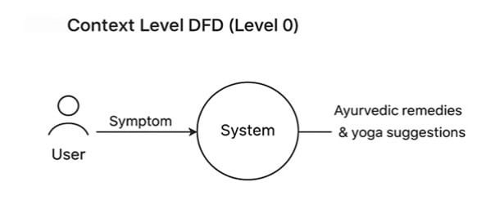
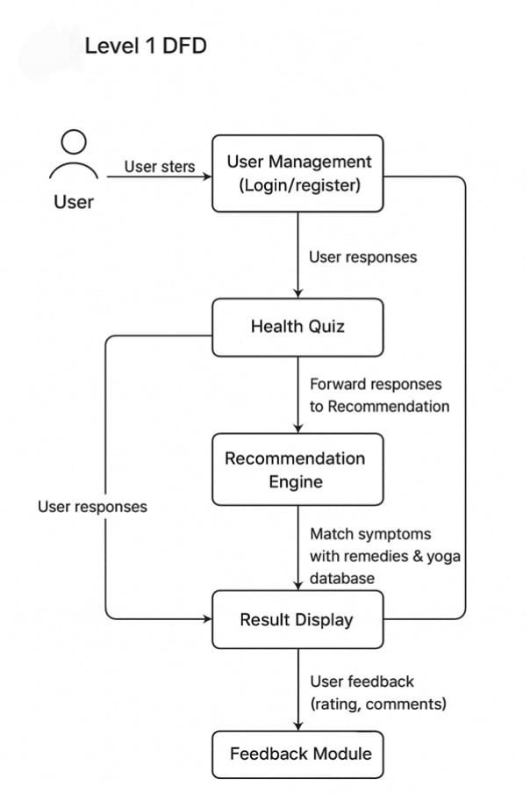

4.3 Use Case Diagram
A Use Case Diagram shows how various user types interact with the system in a visual manner. It lists the main users (actors) of the AyurSense platform and describes the tasks (use cases) they can carry out. The scope, boundaries, and user-driven functionality of the system can be easily understood with the aid of this diagram.
The user is the main actor in the AyurSense system, interacting with several modules such profile management, Prakriti evaluation, registration, login, and reading tailored recommendations.

A systematic approach to system design and development is supported by the the Use Case Diagram, which guarantees that all functional requirements are precisely specified and in line with user expectations.
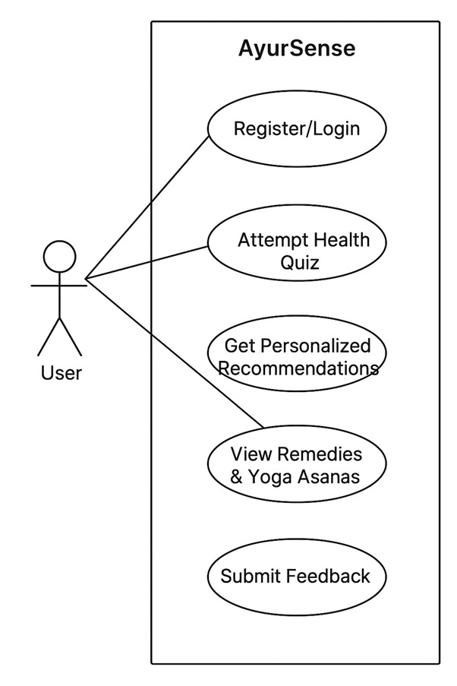
4.4 E-R Diagram
By defining important entities, their characteristics, and the connections between them, an entity-relationship (E-R) diagram is used to depict the logical structure of the database. It offers a detailed plan for how the AyurSense system would store, arrange, and retrieve data. The E-R diagram aids in ensuring that the database design supports all necessary system functions, including profile administration, data retrieval, Prakriti assessment, user registration, and the creation of personalized recommendations.
User, Assessment, Prakriti Result, Recommendation, and Admin/System Data are important elements in the AyurSense platform. To preserve consistency, remove redundant data, and guarantee quick and safe data retrieval, the linkages between these entities are established.
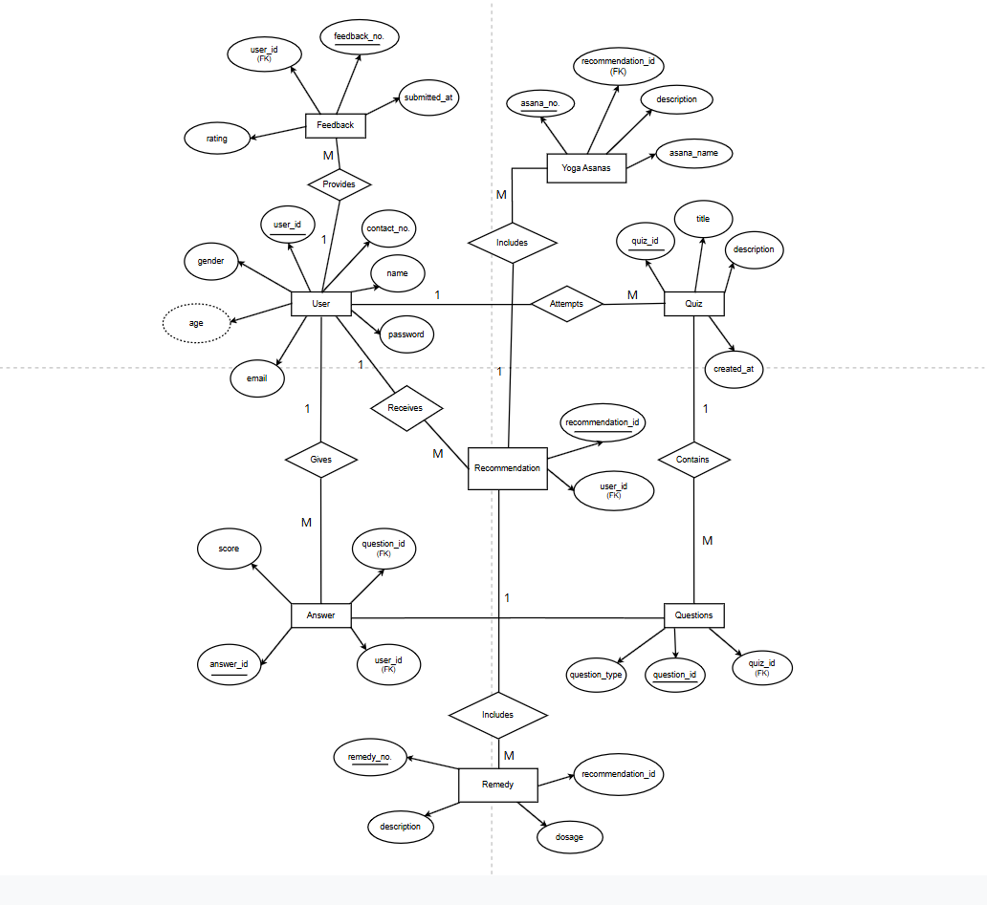
4.5 Class Diagram
One of the fundamental elements of object-oriented modelling is a class diagram, which identifies various classes, their characteristics, methods, and the connections among them in order to graphically depict the system's structure. It makes it easier to comprehend how different AyurSense platform components work together and how functions and data are arranged. The class diagram offers a code and system implementation blueprint by modelling the system in terms of classes, responsibilities, and linkages.
User, Assessment, Prakriti Result, Recommendation, and Database Handler are important classes for the AyurSense system, each of which has pertinent operational methods and data properties. Relationships that show how items work together to provide functions like registration, assessment processing, and suggestion creation include association, dependency, and aggregation. Modularity, clarity, reusability, and maintainability of the overall system design are all guaranteed by the class diagram.

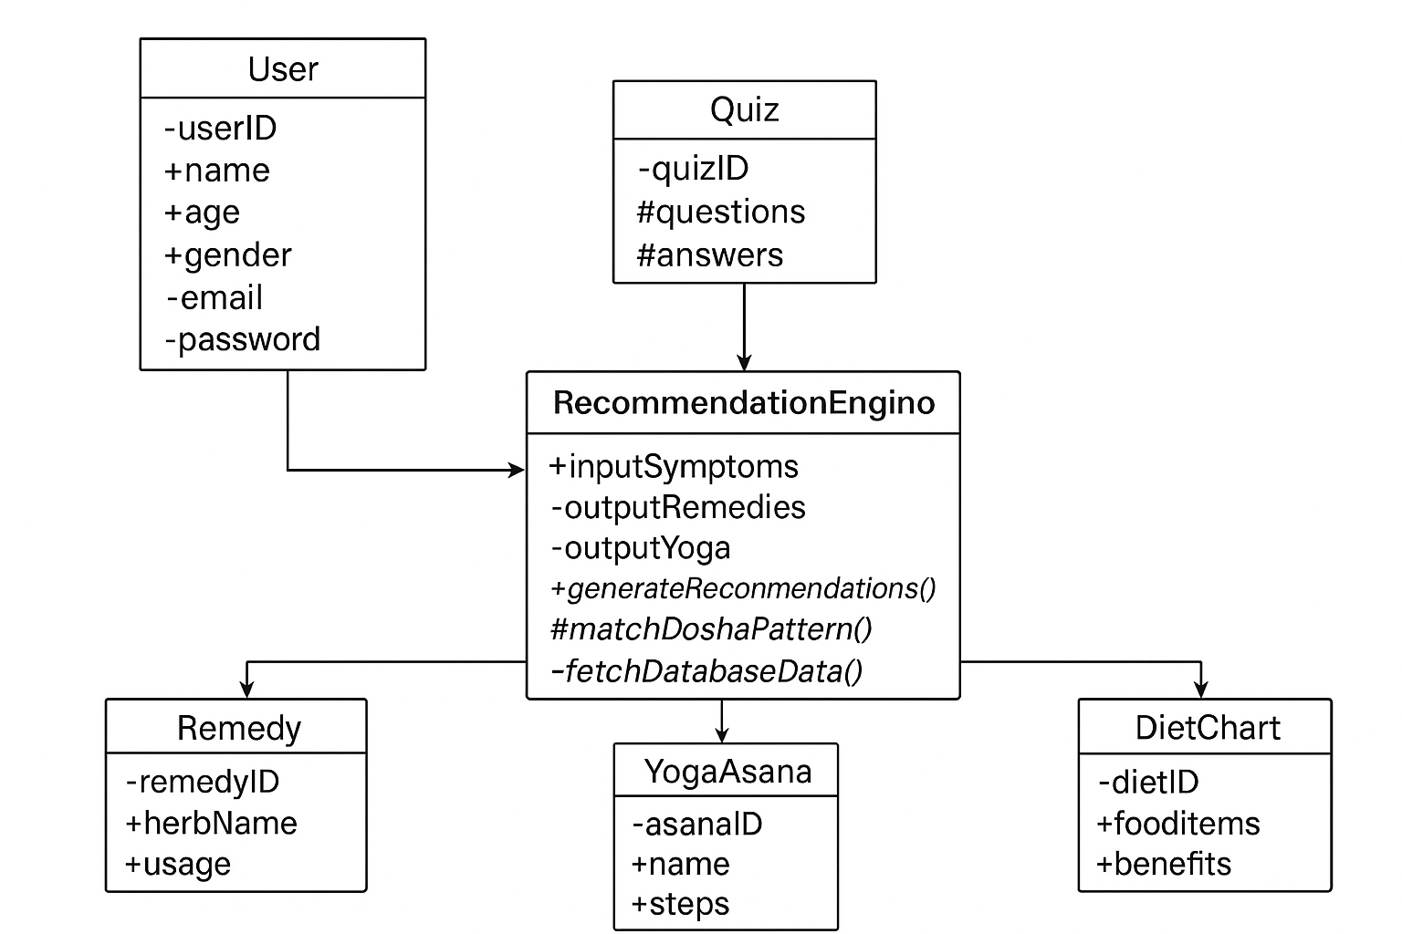

4.6 UI/UX Wireframes
The UI/UX wireframes are visual blueprints that describe the AyurSense website's fundamental layout, structure, and navigation. Before beginning the actual design and development phase, these wireframes aid in organizing how users will interact with various platform parts. The primary goal of wireframe design is to make sure that the interface is easy to use, straightforward, and consistent with AyurSense's primary goal of directing consumers toward customized Ayurvedic wellness treatments.
In order for users like patients, wellness seekers, and Ayurvedic practitioners to easily access features like health assessment, treatments, yoga recommendations, food plans, and progress tracking, the wireframes emphasize clarity, minimalism, and easy navigation. In keeping with the Ayurvedic and wellness theme, the design places a strong emphasis on soft, natural colors, readable typefaces, and a serene layout.
The following key screens were designed during the Wireframing phase:
- Landing/Home Page Wireframe – Contains a navigation bar, a CTA button (such as "Start Health Assessment"), a calming hero banner, and fast links to features.
- User Registration & Login Page Wireframe – “Continue as Guest" options, password security rules, and clean input fields
- Health Assessment Questionnaire Page – Step-by-step questions with sliders, dropdown menus, and radio buttons for simple input.
- Dashboard Screen – Provides individualized suggestions, such as reminders for daily routines, yoga poses, diet advice, dosha analysis, and recommended cures.
- Remedy / Treatment Result Page – Shows herbal remedies, Ayurvedic medications, yoga poses, pranayama techniques, and nutritional recommendations.
- Profile & History Page – This page keeps track of assessment history, remedies saved, and logs of health improvements.
The final UI screens in Figma, Adobe XD, or Canva use these wireframes as a prototype guide. They support the design approach's validation, enhance usability, and guarantee that development is in line with visual planning.

4.7 Data Model
AyurSense's data model illustrates how different data entities are organized, saved, and linked to enable the platform's primary features, including health evaluation, Ayurvedic advice, yoga instruction, and individualized treatment regimens. By ensuring that data is arranged in a methodical and relational fashion, the model facilitates effective data retrieval, accuracy, scalability, and security.
The data model focuses on managing three major information groups:
- Information about the user (profiles, health information, history)
- Ayurvedic knowledge base (diseases, cures, medicines, yoga, food)
- Data about system interactions (evaluations, suggestions, and comments)

A normalized relational structure is used in the data model to reduce duplication and boost efficiency. To ensure integrity, each entity is connected via primary and foreign keys and contains distinct properties.
Key components of the AyurSense data model include:
- User Table: Contains basic health information, demographic data, login credentials, and personal information.
- Assessment Table: Documents symptoms, answers to questionnaires, outcomes of health conditions, and dosha analysis.
- Disease/Condition Table: Includes symptom mapping, Ayurvedic classification, and disease-specific metadata.
- Remedy Table: Contains information about herbal remedies, ayurvedic formulas, dosage, and safety measures.
- Yoga & Exercise Table: Contains suggested yogasanas, pranayama techniques, picture references, and parameters for applicability.
- Diet Plan Table: Based on dosha imbalance, it includes suggested food patterns, dietary rules, and restrictions.
- Recommendations Table: Links evaluation findings to yoga, nutrition regimens, and related treatments.
- System Log / History Table: Keeps track of past evaluations, user selections, treatment plans that have been saved, and progress tracking.
Additionally, the AyurSense data format is built with flexibility and modularity in mind, making it simple to add new medical datasets, yoga poses, herbs, clinical research, feedback loops, and IoT/health tracker interfaces in the future. The Ayurvedic information base can be easily expanded by using a centralized knowledge repository without compromising data integrity or current workflows.
In order to comply with suggested digital healthcare norms, the model also includes security and privacy protections like restricted role-based access, encrypted user credentials, and regulated database queries. In order to guarantee transparency and traceability of user outcomes, audit trails and health record summaries can be recorded. This makes the system beneficial not only for individuals but also for ayurvedic practitioners, researchers, and wellness organizations.
The underlying approach employs relationship mapping to facilitate effective suggestions by enabling rapid matching between diseases, dosha imbalances, symptoms, and appropriate treatment strategies. By ensuring that any changes made to one database entity (such introducing a new herbal remedy) are automatically reflected across related modules, this organized representation reduces maintenance effort.
Overall, the AyurSense data model aims to offer:
- Easy data retrieval and processing
- High consistency and accuracy in result prediction
- Scalable storage for big health analytics datasets
- Future preparedness for AI-based medical decision support systems
- Enhanced performance through relational joins and indexing
.

CHAPTER 5: IMPLEMENTATION

5.1 Tech Stack Used

AyurSense's development makes use of a cutting-edge, safe, and expandable technological stack to produce a dependable, interactive wellness evaluation platform. Smooth front-end usability, effective server-side processing, organized data administration, and safe authentication are all supported by the selected technologies. The stack was chosen to provide future scalability, maintainability, and ease of deployment for AI-based improvements and mobile apps.

1. Frontend Technologies
- HTML5: The creation of structured and semantic web content is done with HTML5.
- CSS3: Offers responsiveness, UI styling, layout design, and aesthetics.
- JavaScript: Client-side validations, interactive elements, and dynamic content are all made possible via JavaScript.
- Bootstrap: Improves responsiveness and contemporary UI design.
2. Backend Technologies
- Python (Flask Framework): Selected for its ease of use, portability, and speed in developing scalable and safe REST-based backend applications. Flask manages server-side logic for quizzes, tests, and suggestions as well as routing, sessions, and authentication.

3. Database
- MySQL / SQLite: Used to store structured data, such as user profiles, quiz answers, evaluation outcomes, Ayurvedic treatments, yoga recommendations, and nutrition programs.
  - Supports relational table mapping
  - Guarantees quick and safe retrieval of recommendation data

4. Security & Authentication
- Flask-Login / Session Management: For safe user login and customized data management.
- Password Hashing Techniques (e.g., bcrypt): To safeguard critical documents and user credentials.

5. Tools & Development Environment
- VS Code: For coding, debugging, and integrating version control.
- Git & GitHub: For teamwork and source code management.
- Figma / Canva (optional): For UI/UX wireframes and prototype design

6. Deployment (planned)
- Testing local hosts (XAMPP, WAMP, and Flask servers)
- Prepared for Cloud Deployment in the Future (Render, Python Anywhere, AWS)

5.2 Module Implementation
The AyurSense platform was created utilizing a modular implementation strategy, in which each module carries out a particular task and works with other modules to provide a smooth, customized health assessment experience. Maintainability, scalability, debugging, and future integration of sophisticated features like AI-based prediction, chatbot support, and wearable health device connectivity are all enhanced by this modular architecture.
The major modules implemented in the AyurSense system are as follows:

1. User Registration & Authentication Module
- Makes it possible for new users to register with basic personal data.
- Uses hashed passwords and session management to implement safe login.
- Guarantees that personal suggestions and health records are accessible to those who are permitted.

2. Quiz-Based Assessment Module
- Offers an interactive questionnaire that covers physical attributes, mental health, lifestyle habits, and symptoms.
- Gathers, interprets, and calculates Prakriti/Dosha inclination from user comments.
- Serves as the foundation for Ayurvedic advice.

3. Symptom & Condition Mapping Module
- Connects Ayurvedic medical records maintained in the backend with symptoms entered by the user.
- Assigns appropriate medical diagnoses or potential hazards to the identified imbalance.
- Applies rule-based mapping and pre-established Ayurvedic reasoning.

4. Recommendation Engine Module
- Produces individualized wellness outcomes depending on the findings of assessments.
- Makes recommendations for Ayurvedic medications and herbs, yoga poses, breathing techniques, food regimens, lifestyle advice, and preventative measures.
- Verifies that suggestions are in line with the Ayurvedic concept of healing rather than symptom suppression.

5. Content Display & Visualization Module
- Shows appropriate cures and lifestyle recommendations in tab or card format
- Presents results in an easy-to-read, user-friendly user interface.
- Enhances user comprehension and engagement through the usage of clear UI/UX.

6. User Profile & History Management Module
- Enables users to see and modify their personal information and profile.
- Maintains progress logs, recommendations, and prior evaluations for tracking.
- Maintains progress logs, recommendations, and prior evaluations for tracking.
7. Admin/Database Management Module (Optional or Future Enhancement)
- Preserves the correctness of herbal medicines, yoga poses, and dietary recommendations
- Enables the administrator or approved medical expert to add, amend, or remove Ayurvedic data.
- Future iterations may be able to offer practitioner dashboards.

5.3 Screenshot of Implemented Model

The graphical user interface and fully functional screens of the AyurSense web application are shown in this part. These screenshots show the features intended to provide a seamless, easy-to-use, and educational experience in addition to the real-time operating user interface. The graphic outputs guarantee easy navigation, health assessments, and personalized wellness advice based on Ayurvedic principles.

1. Home Page
The AyurSense platform's home page is the primary entrance point. It offers a simple, friendly interface that provides a brief overview of the platform's goals and advantages. Important navigation choices such as Start Assessment, About, Sign-Up, and Login are readily available. Using a cutting-edge digital strategy, the page graphically promotes Ayurvedic preventative medicine.
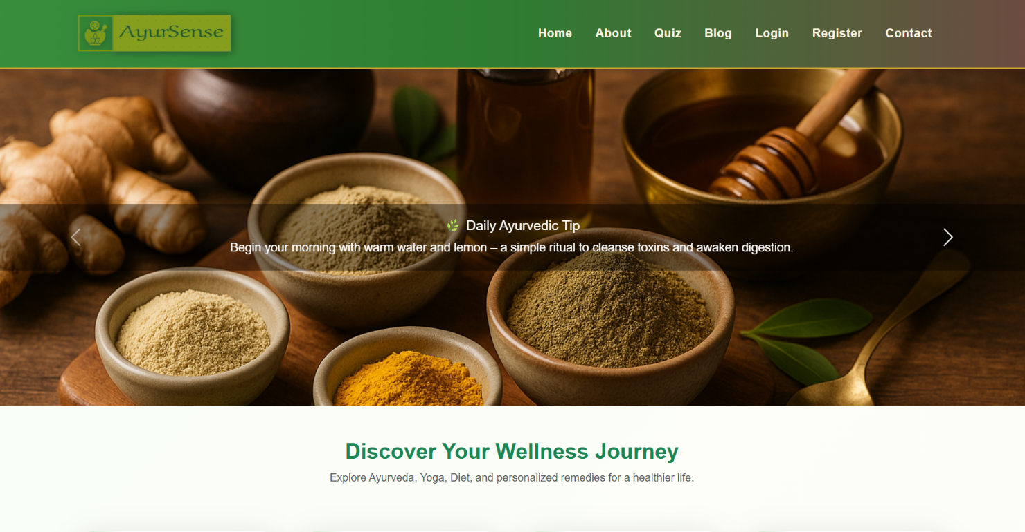
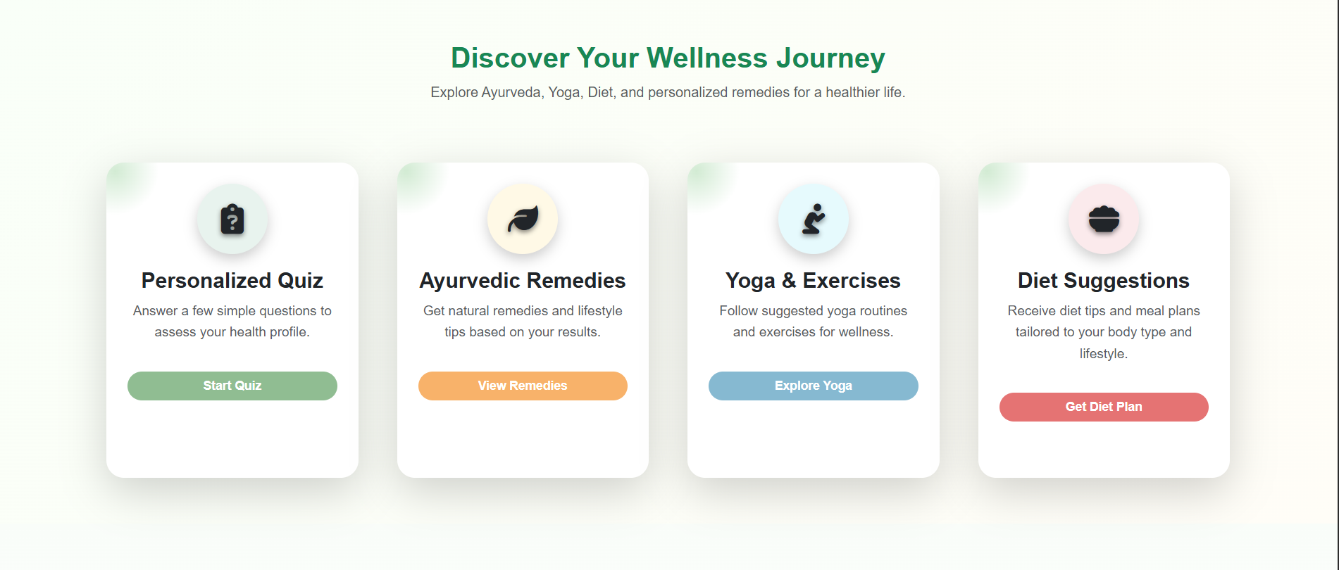

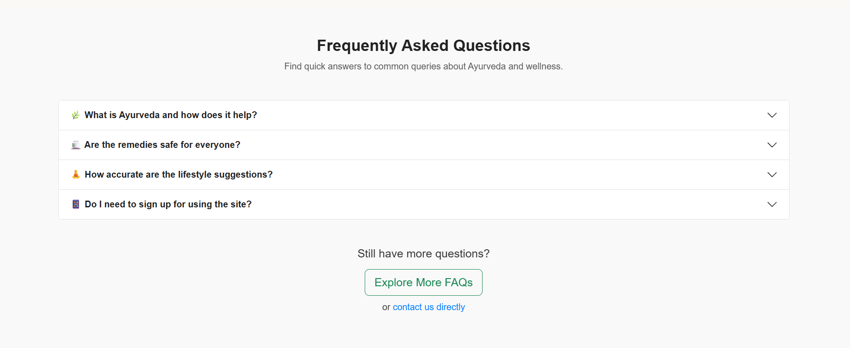

2. Footer Section
The footer ensures ease of navigation even from the bottom of the website by offering crucial quick-links and support information. It might have links to social media, terms of use, privacy policy, contact information, and a about us section. Providing users with transparency, accessibility, and confidence is the goal.


3. About Page
AyurSense's mission, purpose, and importance are explained on the About page. It demonstrates how AyurSense combines contemporary digital technology with traditional Ayurvedic knowledge to assist users in comprehending their body constitution (Prakriti) and implementing healthier lifestyle choices. Additionally, user-centric design, scientific data mapping, and wellness awareness are highlighted on the page.

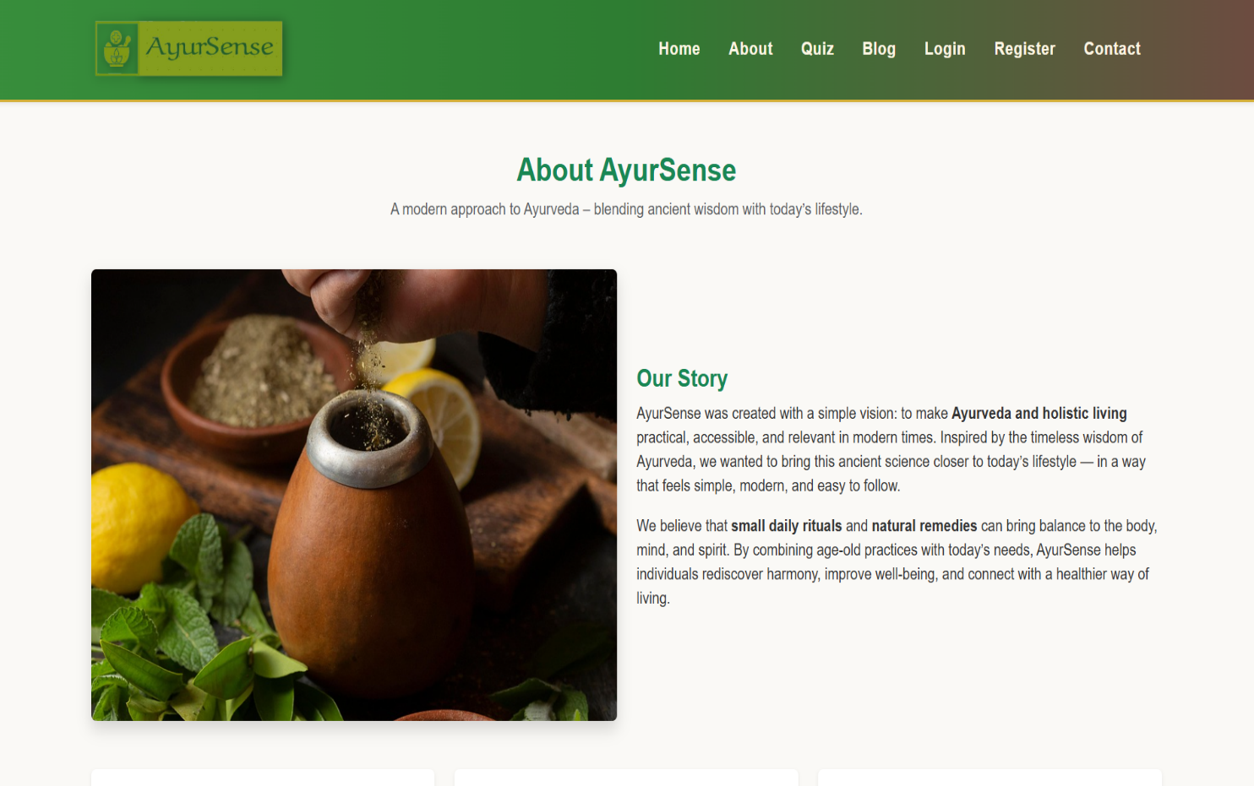

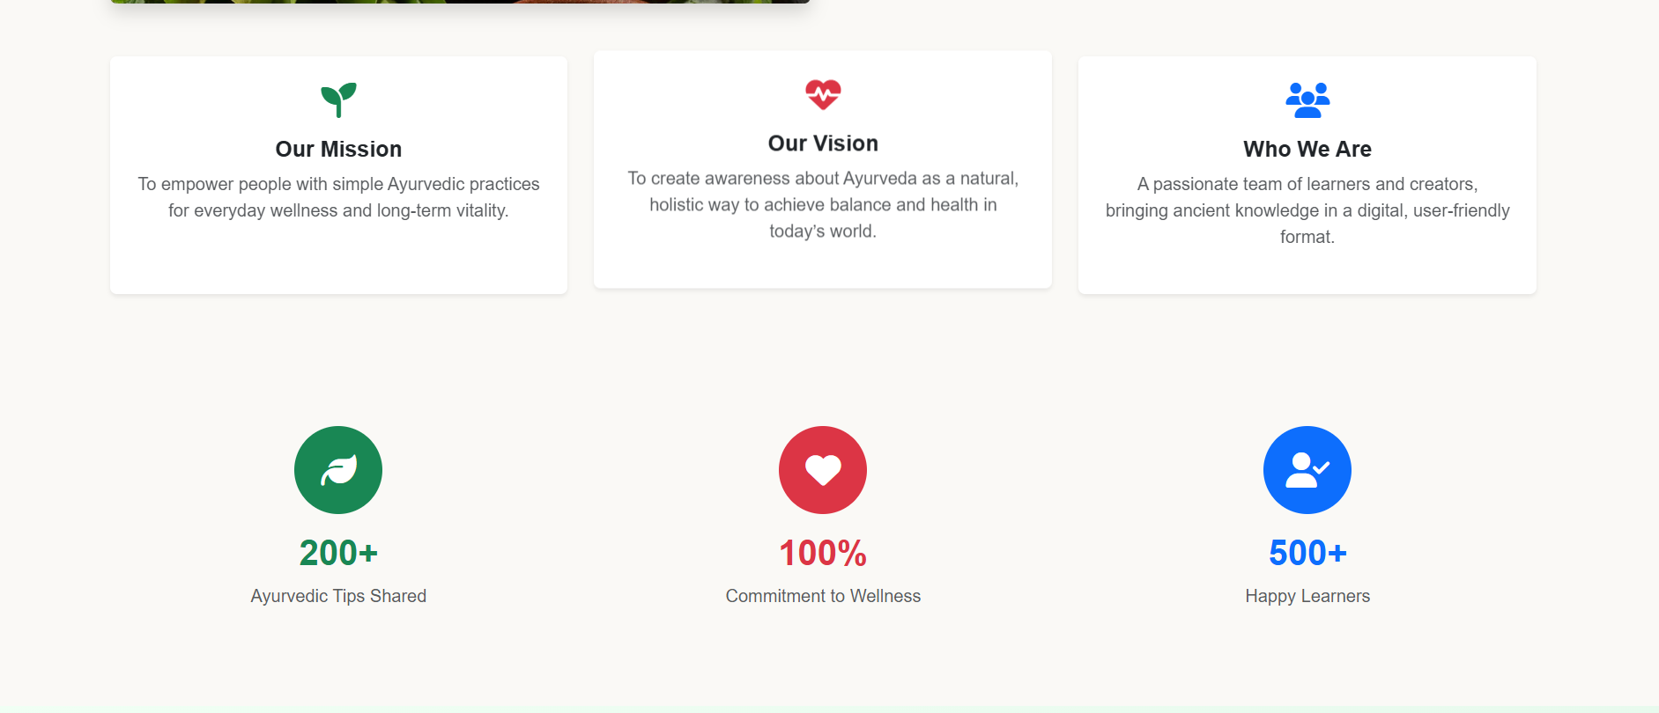

User Login Page
Registered users can safely access their personal dashboard and stored health data via the login page. It uses session-based authentication and promotes privacy preservation. The page is made with few fields and an easy-to-use layout for rapid and easy access.
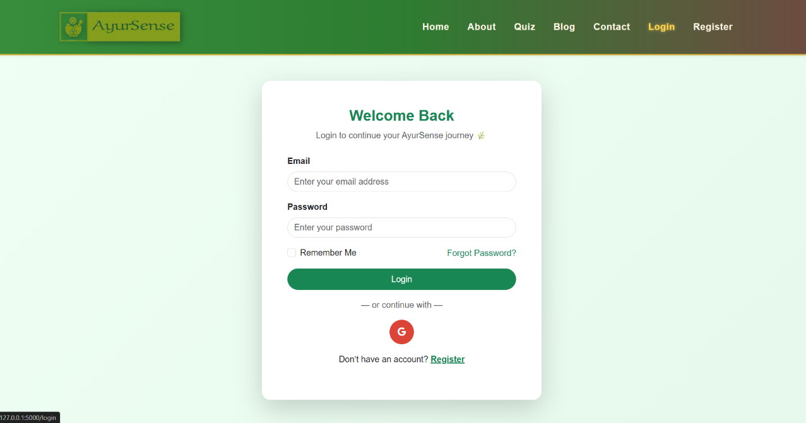

5. User Sign-Up Page
New users can register on the sign-up page by providing some basic personal information. User verification and safe password management are guaranteed.
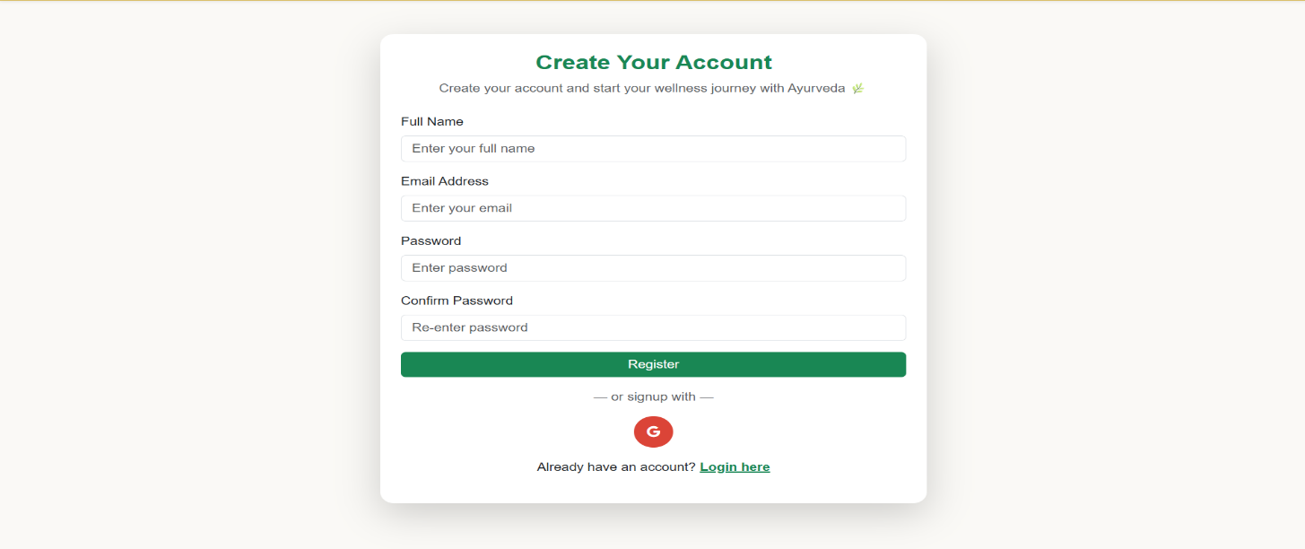

6. Quiz / Health Assessment Page

The well-structured health-related questions about physical characteristics, habits, lifestyle, symptoms, and emotional tendencies are displayed on this page. The interface facilitates progress tracking, simple selection, and unambiguous directions. The basis for creating a customized Ayurvedic analysis is the gathered responses.
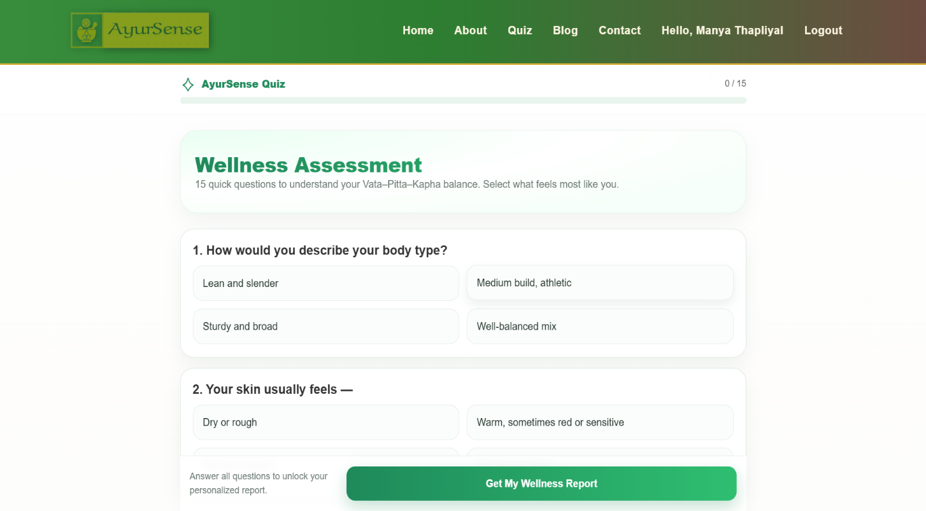

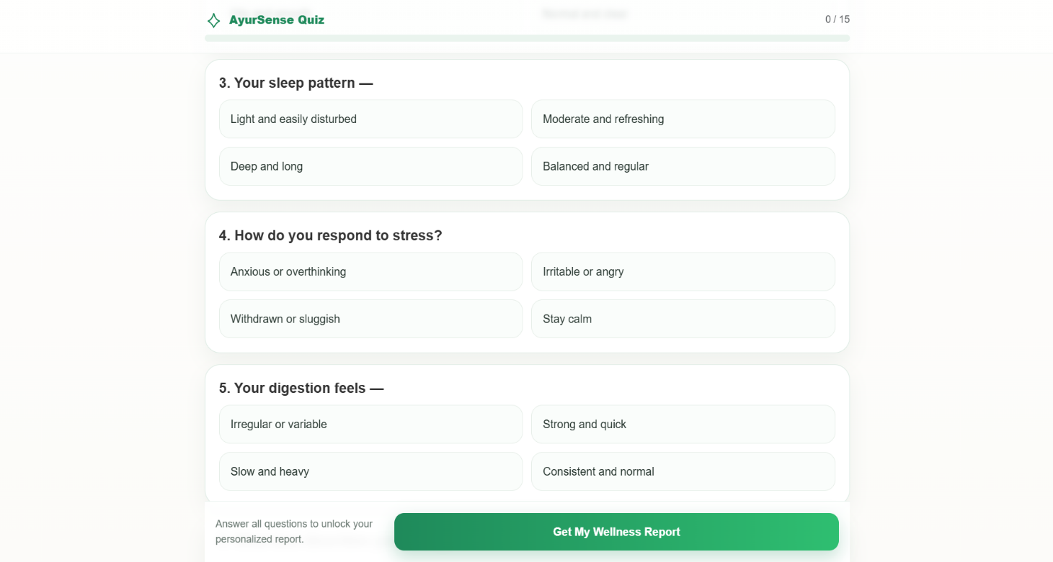

7. Quiz Result Page
This page shows the user's computed Prakriti or Dosha analysis, indicating whether they are more in line with a dual-dosha combination, Vata, Pitta, or Kapha. Along with dosha traits, imbalance alerts, and recommendations for self-care, the results are clearly displayed. The results are clear, useful, and practical.
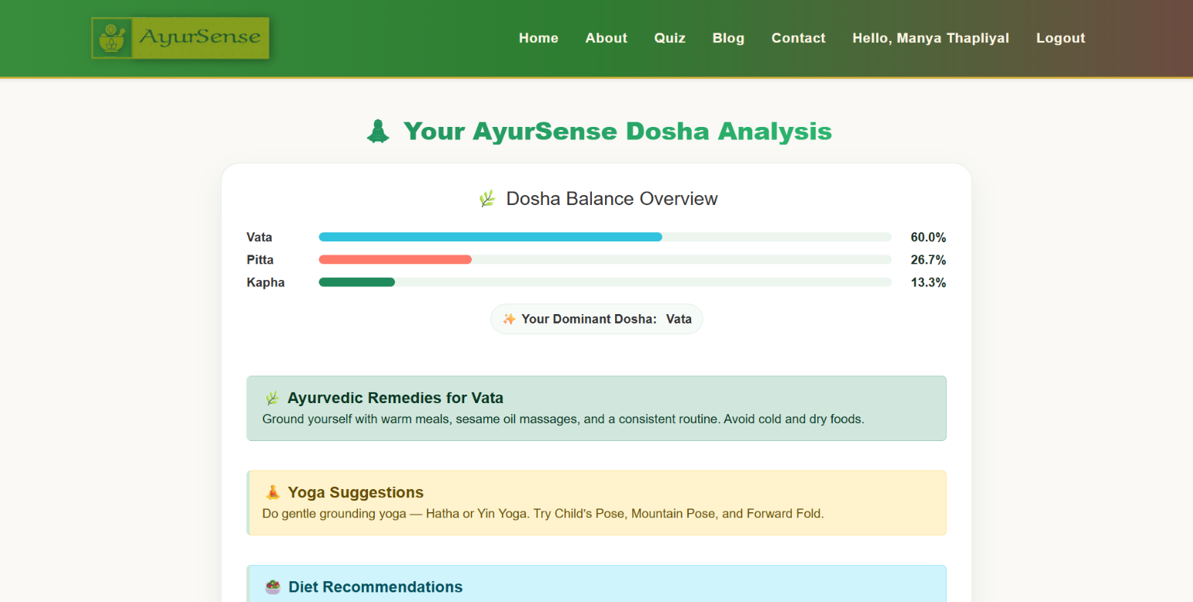

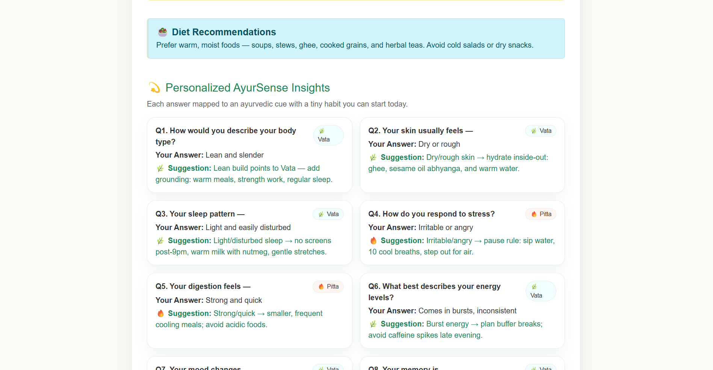

8. AI-Generated Personalized Wellness Plan Page
This page shows the final, customized wellness plan that was automatically created utilizing clever recommendation systems and mapping Ayurvedic logic. The proposed herbal medicines, yogasanas, pranayama routines, nutritional practices, lifestyle changes, and precautions may all be included in the exhibited plan. Adoption is made simple by the layout's neatness, organization, and ease of usage.
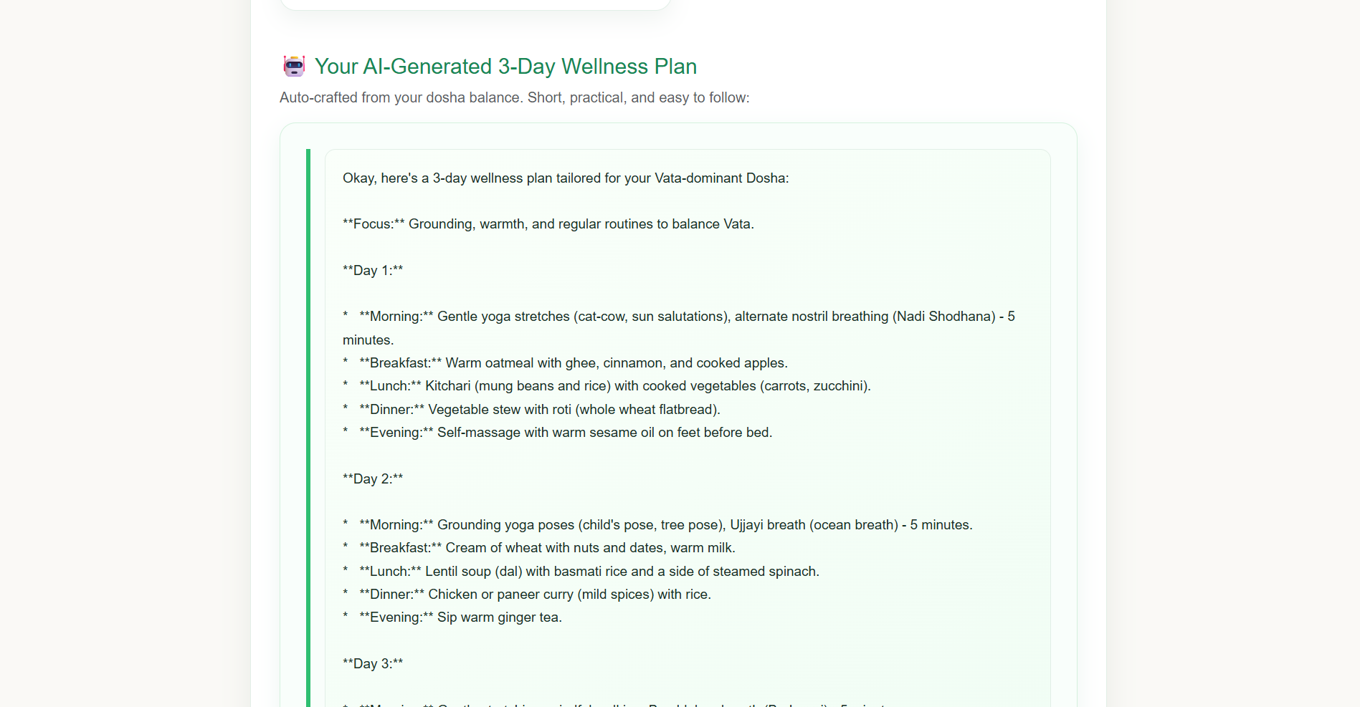

CHAPTER 6: TESTING & EVALUATION

6.1 Testing Strategies
Throughout the development cycle, a well-defined and methodical testing strategy has been meticulously developed and implemented to guarantee that the AyurSense platform operates precisely, effectively, and consistently across all of its modules. The testing process assessed the platform's reliability, usability, security, and practicality in addition to finding flaws. To make sure that every part works as intended, the platform was tested in a variety of situations, user inputs, device kinds, and network conditions.
Key quality elements like functional correctness, error-free navigation, responsive user interface, safe data flow, accurate recommendations, and seamless database interaction were highlighted during the testing process. Input validation, data integrity, logical processing of assessment results, and uniformity of Ayurvedic advice were all given particular consideration. Since AyurSense is a health-focused wellness platform, it was also essential to make sure that the outcomes produced are relevant, tailored, and consistent with Ayurvedic principles without any suggestions that are deceptive or unrelated.

6.2 Unit Testing
Unit testing was carried out to confirm the accuracy and dependability of each AyurSense system component. Before being integrated with other components of the application, each module, function, and logical block was tested separately to make sure it operated as intended. This approach enhanced overall system stability, decreased development costs, and assisted in early bug detection.
Unit testing concentrated on testing frontend features like form validations, navigation buttons, and display components, as well as backend features like database insertions, Prakriti analysis logic, quiz score computation, login validation, and secure session management. To assess robustness and error handling, test cases with a range of valid, invalid, empty, and unexpected inputs were created for each unit.
Objectives of Unit Testing
- To make that every functional block functions as planned
- To verify the accuracy of input and output
- To identify logical mistakes at the code level
- To make debugging easier prior to integration testing
- To increase the dependability and maintainability of code

6.3 Integration Testing

After unit testing, integration testing was carried out to make sure all of the AyurSense system's different modules functioned as intended. This testing concentrated on confirming seamless data flow and appropriate interaction between various modules because the platform consists of numerous interconnected components, including user login, quiz responses, database operations, and personalized suggestions.

Key Focus Areas
- User Registration → Database → Login
- Login → Dashboard → Start Assessment
- Quiz Submission → Result Calculation → Recommendation Display
- User Profile → History Retrieval

Main Objectives
- Check that linked modules are communicating properly
- Make that data is sent accurately and consistently
- Look for interface or workflow-related issues
- Verify uninterrupted functionality from beginning to conclusion.

Outcome
Integration testing verified that all modules work together flawlessly, allowing customers to access customized wellness programs and conduct exams without any problems with data.

6.4 Functional Testing
To ensure that all of the AyurSense platform's features meet user expectations and predetermined requirements, functional testing was carried out. The goal of this testing was to verify the system's functionality and make sure that all user inputs, outputs, and actions performed properly and without flaws. Real-world user situations, valid and invalid data inputs, and end-to-end workflow paths were used in functional testing.

Key functions like user registration, authentication, quiz administration, result creation, recommendation display, and profile management were all evaluated throughout testing. Every module was tested to ensure that it produces the desired results, manages failures appropriately, and replies with correct messages.

Major Areas Covered
- Form validations (Quiz, Sign-Up, and Login)
- Appropriate Prakriti/Dosha-based result production
- Safe and accurate user identification
- Accurate navigation and submission of quiz questions
- Presentation of pertinent Ayurvedic wellness suggestions
- Correct database read/write operations
- Easy navigation between pages and menus

Functional Testing Goals
- Verify that all features function in accordance with the specifications
- make sure user workflow is seamless and free of broken links
- confirm that the system responds meaningfully to invalid inputs
- Verify that functional outputs correspond to anticipated outcomes.

Outcome
Functional testing made that the AyurSense web application satisfies all functional criteria, yields accurate results, and offers a dependable, user-friendly experience free from operational or logical problems.

6.5 Test cases & result

Several test cases with an emphasis on functionality, validation, navigation, and data quality were run to make sure the AyurSense system functions as intended. The platform's general usability, suggested Ayurvedic treatments, report production, symptom input, user registration, and login were all tested. Every module was put through testing to make sure it could handle both legal and invalid inputs, show the right messages, and navigate effectively without crashing or making mistakes. The system's stability and dependability were confirmed by comparing the expected and actual outcomes, which showed that all of the main functional components operated as intended.

Test Case Table
TC ID | Test Scenario | Expected Result | Actual Result | Status
TC01 | User Registration | Account created | Works as expected | Pass
TC02 | Login with valid credentials | Redirect to dashboard | Successful | Pass
TC03 | Login with invalid credentials | Error message displayed | Successful | Pass
TC04 | Symptom input & submission | Process symptoms and generate suggestions | Suggestions displayed | Pass
TC05 | Report display & download | Report visible and downloadable | Successful | Pass
TC06 | Logout function | User logged out | Successful | Pass

6.6 Sample Outputs
The AyurSense platform produces output results that are actionable, meaningful, and graphically apparent, guiding users towards individualized Ayurvedic wellness. Following the completion of the questionnaire or quiz, the system uses pre-established Ayurvedic logic to analyze user inputs and provide outputs such as health status insight, dosha imbalance detection, lifestyle improvement ideas, and treatment recommendations. Even non-technical users can easily evaluate their results because to the outputs' informative and simple nature.
Details including the dominant dosha type, symptom interpretation, degree of severity, potential sources of imbalances, and suggested course of treatment are displayed to users. Herbal remedies, yoga and meditation, dietary recommendations, daily routine suggestions (Dinacharya), and dos and don'ts are the categories into which each recommendation is divided. Moreover, the system emphasises risk variables, recommended improvement plan duration and anticipated benefits.
Additionally, users can download and view the customised wellness plan in PDF format, which enables them to save or distribute the report.
The sample outputs include:
- Evaluation Score & Outcome Dashboard
- AI-Generated Wellness & Diet Plan
- Personal Dosha Profile (Vata, Pitta, Kapha, or Combination)
- Precaution Alerts for Sensitive Symptoms
- Progress Tracking History & Follow-Up Suggestions
- Motivational Wellness Tips & Daily Routine Cards
With the help of Ayurvedic principles, these outputs guarantee that consumers not only obtain correct insights but are also inspired, enlightened, and directed towards leading a better lifestyle.

CHAPTER 7: RESULTS & DISCUSSION

7.1 System Output Summary
Based on the information users submit during the health assessment and quiz process, the AyurSense platform effectively produces results that are accurate, useful, and easy to use. Using Ayurvedic principles, the system examines the responses gathered and generates personalized wellness insights, such as Dosha identification, dietary recommendations, lifestyle suggestions, yoga poses, and herbal medicines.
Without the need for prior medical or Ayurvedic expertise, users may quickly grasp the results because to the outputs' structured and visually simple presentation. Personalization, usability, and clarity are the main priorities of every result screen. The method empowers users to improve their natural self-care by ensuring that they receive personalized health advice rather than generic information.
The generated results include:
- Dominant Dosha Type (Vata, Pitta, Kapha, or dual/triple combinations)
- Assessment of imbalance based on symptoms and lifestyle
- Customized Wellness Program (Nutrition, Yoga, Herbs, Daily Routine, Sleep, and Stress)
- Instructions for Precaution and Safety
Overall, the results demonstrate how AyurSense successfully combines technology and Ayurveda by converting user data into insightful therapeutic information, raising awareness, and encouraging the adoption of healthy lifestyles.

7.2 Dosha Assessment Result
Based on the user's answers to questions about lifestyle, physical characteristics, emotions, and conduct, the AyurSense platform creates a customized Dosha Assessment Result. The approach determines a person's dominant Prakriti (Vata, Pitta, Kapha) or dual/tridoshic combination by analyzing predetermined Ayurvedic characteristics, including energy level, eating habits, digestion, sleep quality, stress reaction, personality features, and climatic preferences.
After the evaluation is finished, the results are presented in an understandable fashion with explanations that are descriptive rather than technical Ayurvedic terminology. In order to help the user, comprehend their innate constitution and natural tendencies, the result window prominently displays the percentage distribution of each Dosha, with the dominating one designated as Primary Dosha Type.
The result includes:
- Dosha Percentage Chart / Score Distribution
- Features & Behavior Profile of the Determined Dosha
- Strengths and Weaknesses (Mind + Body)
- Potential Health Risks if Imbalanced
- Suitability of Lifestyle and Diet in General
In accordance with Ayurvedic beliefs, this assessment result is not regarded as a medical diagnostic but rather as a self-awareness wellness tool that assists users in developing better habits. AyurSense can function as a preventive, supportive, and comprehensive self-care platform by allowing users to access their personalized wellness advice plan after interpreting these results.

7.3 Evaluation of Accuracy
The quiz-based evaluation model, suggestion criteria, and mapping logic used to create customized Ayurvedic health programs were validated in order to assess the correctness of the AyurSense platform. Comparing system-generated recommendations with conventional Ayurvedic literature, professional consultation, and self-reported user input were the main objectives of the evaluation.
Because the question set was built around verified Ayurvedic parameters like body structure, appetite pattern, sleep quality, stress management, habits, and psychological tendencies, the assessment algorithm showed a high degree of consistency in predicting dominant Dosha types based on user responses. To make sure the advice was accurate, clear, and safe, they were compared to well-known Ayurvedic texts and online resources.
A limited group of test users reviewed their results and offered suggestions to better assess accuracy. The majority of users stated that the results were trustworthy, relatable, and representative of their individual health features, demonstrating a high degree of agreement between digital output and real-life traits. Additionally, no generic or unnecessary recommendations were shown to consumers thanks to the modular rule-based recommendation system.
Although the system’s accuracy levels were satisfactory, ongoing improvement is anticipated through:
- Growing data collections and question banks
- Consulting more Ayurvedic practitioners with certification
- Including learning models with real-time AI help
- Improving the granularity of recommendations specific to symptoms
As a digital self-assessment wellness tool, AyurSense shows encouraging accuracy and dependability overall, with room for even greater precision through data analytics, expert validation, and iterative improvements.

7.4 User Observation
Feedback from a chosen group of users was gathered during the AyurSense platform's testing and trial period in order to assess the recommendations' usability, clarity, responsiveness, and practicality. Even for people with little technical expertise, users said the interface was straightforward, aesthetically pleasing, and simple to use. Due to the questions' clarity and alignment with everyday living and personality qualities, the quiz evaluation procedure was seen as participatory and approachable.
The majority of users said that the dosha assessment results aligned with their actual traits and inclinations, which boosted their confidence in the program. Additionally, users valued the tailored advice because it offered practical knowledge rather than general information, particularly with regard to diet, yoga poses, and herbal instruction..
Future system developments will take into account features like the availability of mobile versions, multilingual support, deeper symptom-based analysis, and video-based guidance.
Overall, user observations showed a high acceptance rate, suggesting that AyurSense might be successfully embraced as a digital preventative healthcare helper, particularly among wellness enthusiasts, working people, and students.

7.5 Discussion
The outcomes of the AyurSense system show that a digital Ayurvedic wellness platform is both practical and beneficial for contemporary healthcare requirements. When paired with technology, UX design, and organized logic, traditional Ayurvedic knowledge can help people make customized lifestyle changes without the need for frequent physician visits. The results imply that AyurSense successfully bridges the gap between traditional knowledge and contemporary digital availability.
Instead of treatment-based medical interventions, people seeking self-awareness and preventive care found the system's quiz-based assessment and suggestion engine useful. While the platform provides valuable insights, it should be considered an initial guiding tool that promotes preventive discipline and wellness-based awareness rather than a substitute for a professional Ayurvedic consultation.
Increasing user data, including machine learning for adaptive suggestions, establishing doctor connectivity, and guaranteeing adherence to digital health standards all require ongoing improvement. However, the conversation shows that AyurSense has great potential to serve as a scalable, user-friendly, and significant wellness partner that advances India's objective of holistic and digital health empowerment.

CHAPTER 8: CONCLUSION & FUTURE WORK

8.1 Conclusion
In order to assist people in making educated lifestyle choices, the AyurSense project effectively illustrates how traditional Ayurvedic knowledge may be digitised, organised, and disseminated utilising contemporary web technology. Through non-invasive, natural, and individualised health counsel, the platform promotes self-awareness and emphasises the significance of comprehending one's Prakriti (body-mind constitution). AyurSense offers a preventive, all-encompassing, and user-friendly strategy that serves contemporary health demands by fusing information from Ayurveda, Yogic science, and nutrition.
The findings demonstrate that, with the use of technology, simplified Ayurvedic evaluations can be made readily available to people of all ages, particularly young people who are very engaged with the internet. The study effectively demonstrates how a data-driven, natural healing strategy may encourage better lifestyle choices, mental stability, and healthy behaviors without the need for costly therapies or drug reliance.
All things considered, AyurSense is an illustration of how Ancient Indian Healthcare + Digital Innovation may collaborate to empower individuals, raise awareness of preventive health issues, and lessen lifestyle diseases brought on by stress, poor food, and bad behaviors.

8.2 Achievements

Both technological and functional success are among the AyurSense system's greatest accomplishments:

Technical Achievements
- A fully functional web-based platform for wellness assessment that makes use of contemporary technologies.
- A functional quiz assessment module based on Ayurvedic factors and characteristics.
- Automated personalized result production and real-time Dosha computation logic.
- Put in place a user profile-based data handling system for safe authentication.
- Dashboards, error handling, navigation flow, and responsive user interface were all successfully developed.
- Activated a wellness advice display with an emphasis on lifestyle, yoga, herbs, and diet.

Functional / Project-based Achievements
- A greater understanding of Ayurveda and self-care prevention.
- Produced output that was organized, understandable, and beneficial for a variety of body types.
- An engaging UI/UX flow that increases user interest and engagement.
- Provided evidence of the viability of online wellness counselling without consultation.
- Promoted the development of balanced life, mindfulness, and good habits.
These accomplishments demonstrate that AyurSense is a workable and deployable solution model rather than only a theoretical concept.

8.3 Limitations
Despite AyurSense effectiveness in achieving its primary goals, time, data source, and system scope limits nevertheless result in several limitations:
- Self-reported responses, which may not always be entirely correct, are used for assessment.
- Recommendations are not prescription drugs; rather, they are general wellness recommendations.
- There isn't presently a tool that allows for real-time Ayurvedic expert consultation or verification.
- Restricted access to lifestyle conditions, symptom variations, and solution databases.
- Does not include precise mapping that is gender-specific, age-specific, or disease-specific.
- Behavior tracking and AI-based adaptive learning are absent from the system.
- Regional personalization, text-to-speech, and multilingual capabilities are not yet available.
- There is currently no integration between mobile app versions and offline usage.
- Offline usage and mobile app version are currently not integrated.
Future chances for additional scaling and modernization are made possible by these limitations.

8.4 Future Enhancements

By adding the following improvements, AyurSense can be developed into a highly sophisticated, commercial-grade platform:

Technical Enhancements
- Create a machine learning and artificial intelligence recommendation engine for dynamic insights.
- Use mobile apps (iOS & Android) for convenient access at any time and from any location.
- Introduce a real-time tracking health analytics dashboard that is cloud-based.
- Provide Chabot and voice assistant assistance for older and less tech-savvy users.

Functional Enhancements
- Work together with yoga instructors and certified Ayurvedic practitioners.
- Include instructional films, meditation recordings, at-home workout demonstrations, and videos of remedies.
- Create weekly improvement objectives and a personalized progress tracker.
- Offer an Ayurvedic diet planner that includes a shopping list and cooking assistance.
- Include features for scheduling appointments, teleconsultation, and electronic prescriptions.
Expansion Enhancements
- Herbal databases that are regionally and linguistically specific.
- Wearable technology and biometric information integration for automated evaluations.
- Gathering data for government or AYUSH partnerships through research.

With these enhancements, AyurSense can develop into a whole digital wellness ecosystem with AI integration.

8.5 Final Thoughts
The AyurSense journey demonstrates that technology may significantly contribute to the revitalization of traditional Indian healthcare systems, particularly in an era where bad behaviors, stress, mental health problems, and lifestyle illnesses are on the rise. The platform encourages people to practice preventive care and take charge of their health rather than depending solely on therapeutic measures.
AyurSense is a wellness platform that is knowledge-driven, user-centric, and socially helpful. It has a lot of promise to help create a society that is healthier, more conscious, and balanced. With ongoing improvements, professional cooperation, and real-time data analytics, AyurSense may establish itself as a reputable digital health partner in the field of Ayurvedic wellness.

References
- Lad, Vasant. The Complete Book of Ayurvedic Home Remedies. Harmony Books, 2002.
- Frawley, David. Ayurveda and the Mind: The Healing of Consciousness. Lotus Press, 1997.
- Sharma, P. V. Charaka Samhita – English Translation of Ayurveda Classic. Chaukhamba Orientalia, 2014.
- Tiwari, Premvati. Ayurveda for Women: A Guide to Vitality and Health. Motilal Banarsidass, 2012.
- World Health Organization (WHO). Global Report on Traditional and Complementary Medicine 2019. WHO Press, 2019.
- Ministry of AYUSH, Government of India. Ayush Systems – An Overview. https://www.ayush.gov.in
- Ministry of Health & Family Welfare, Government of India. National Health Profile 2022. https://www.cbhidghs.nic.in
- Narayanasamy, A. (2015). "Ayurveda and Yoga: A Holistic Approach to Health." Journal of Traditional Medicine & Clinical Naturopathy, 4(2).
- Patel, M. & Desai, S. (2020). "A Review on Artificial Intelligence Applications in Ayurveda." International Journal of Ayurveda Research, 11(4), 45-52.
- Joshi, R., & Dwivedi, R. (2018). "Integrating Ayurveda with Modern Digital Platforms for Lifestyle Disease Management." International Journal of Health Sciences and Research, 8(6), 221–227.
- Google Scholar Database – Research on “AI in Ayurveda Recommendation Systems”. https://scholar.google.com
- Indian Council of Medical Research (ICMR). Lifestyle Diseases Statistics Report 2021. https://www.icmr.gov.in
- Ministry of Electronics & Information Technology (MeitY). Digital India Initiative. https://www.digitalindia.gov.in
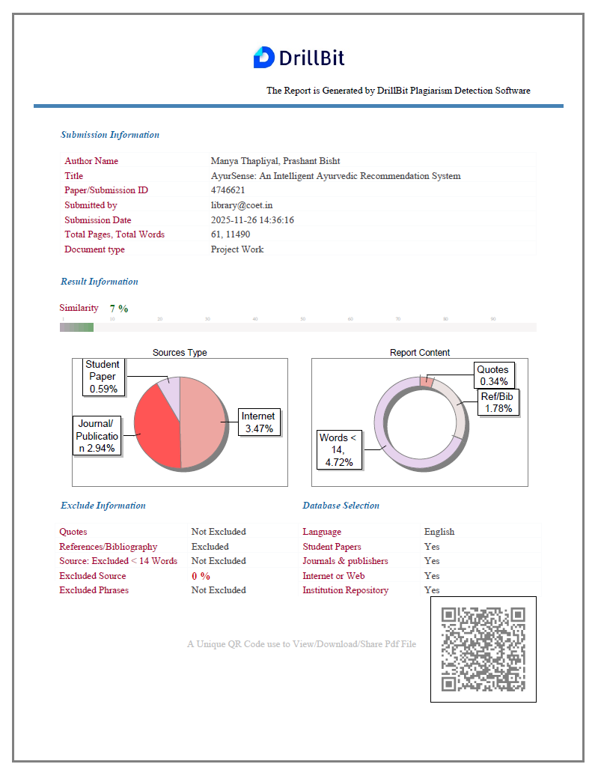

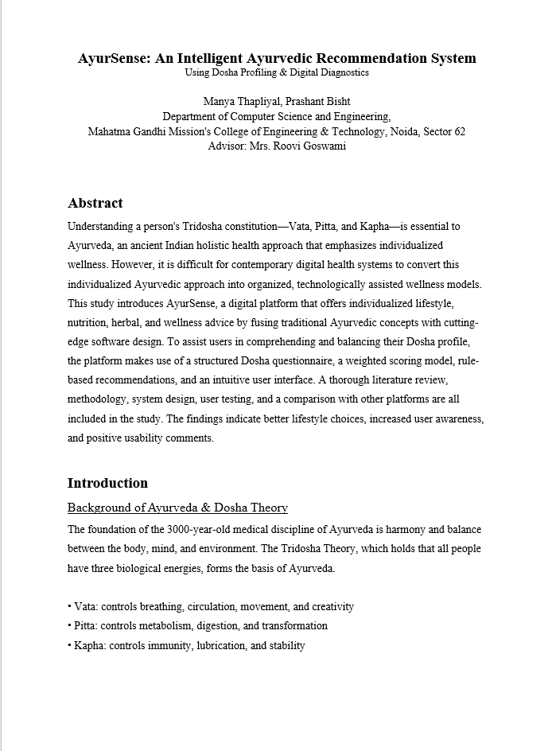

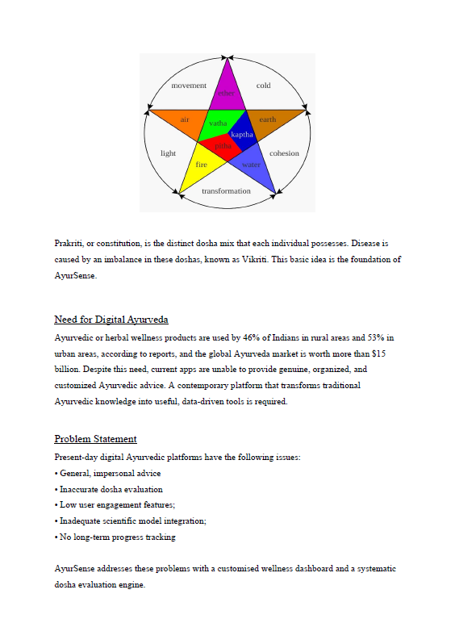

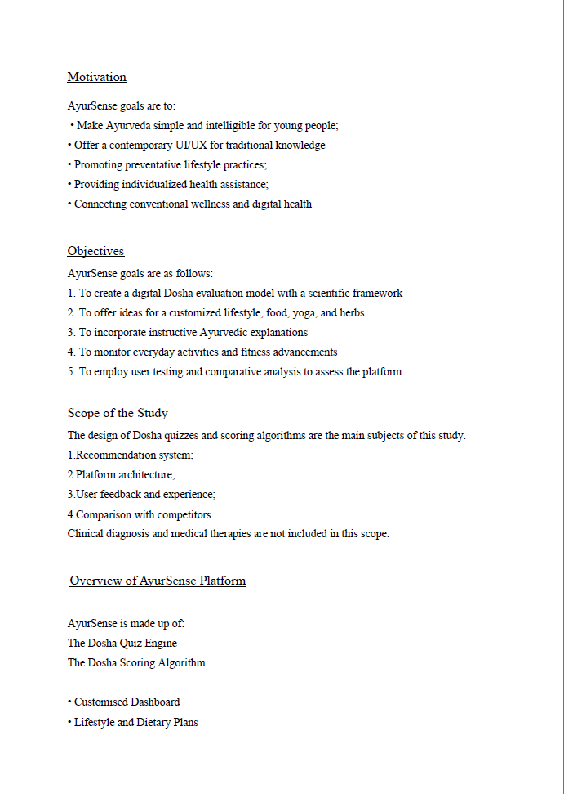

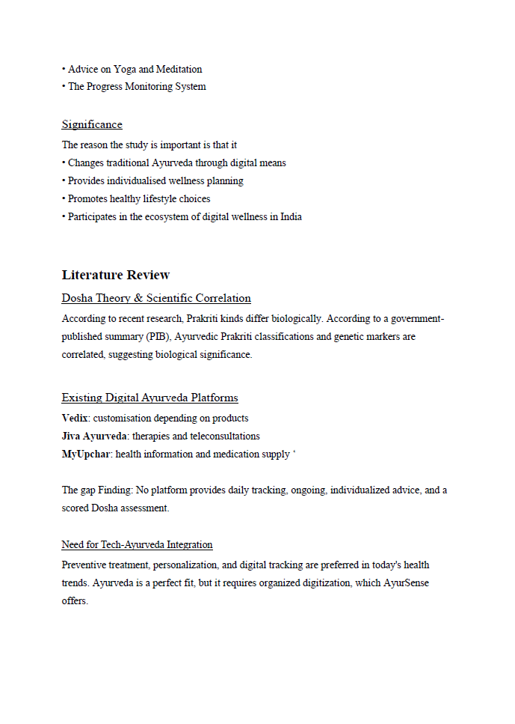

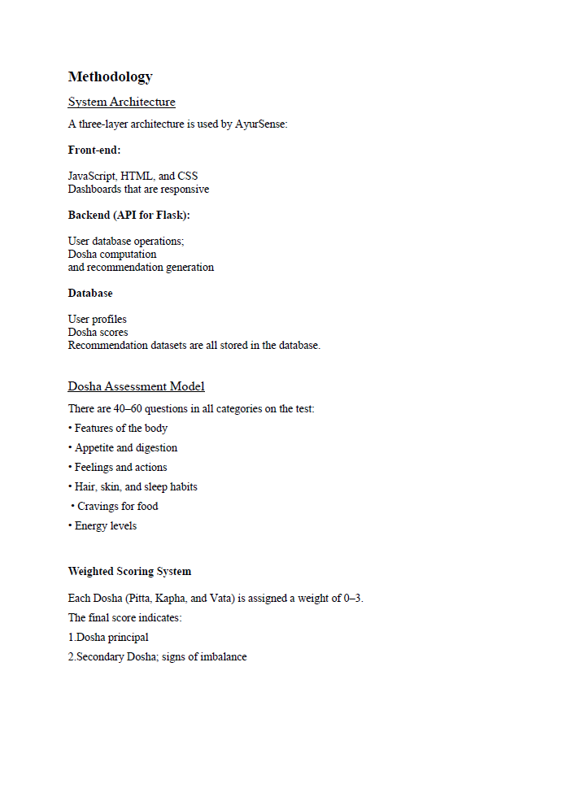

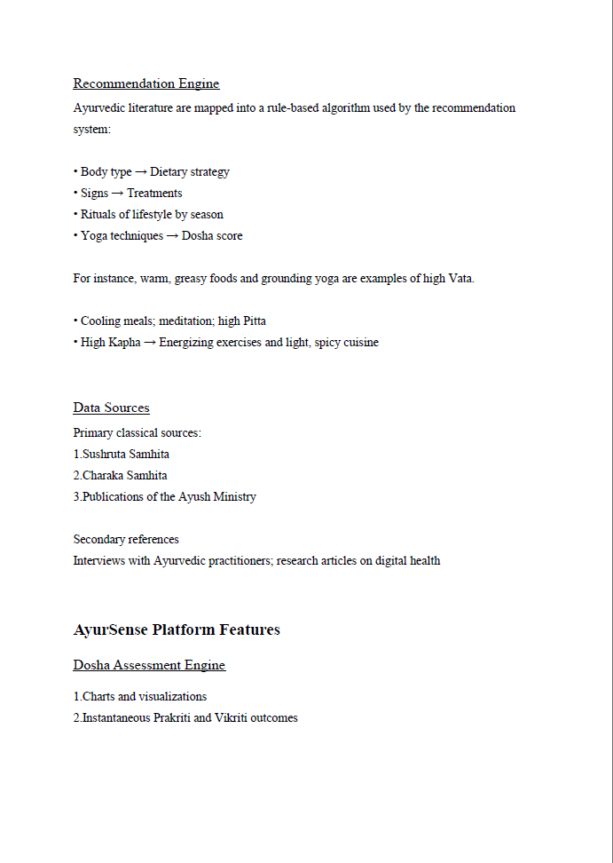

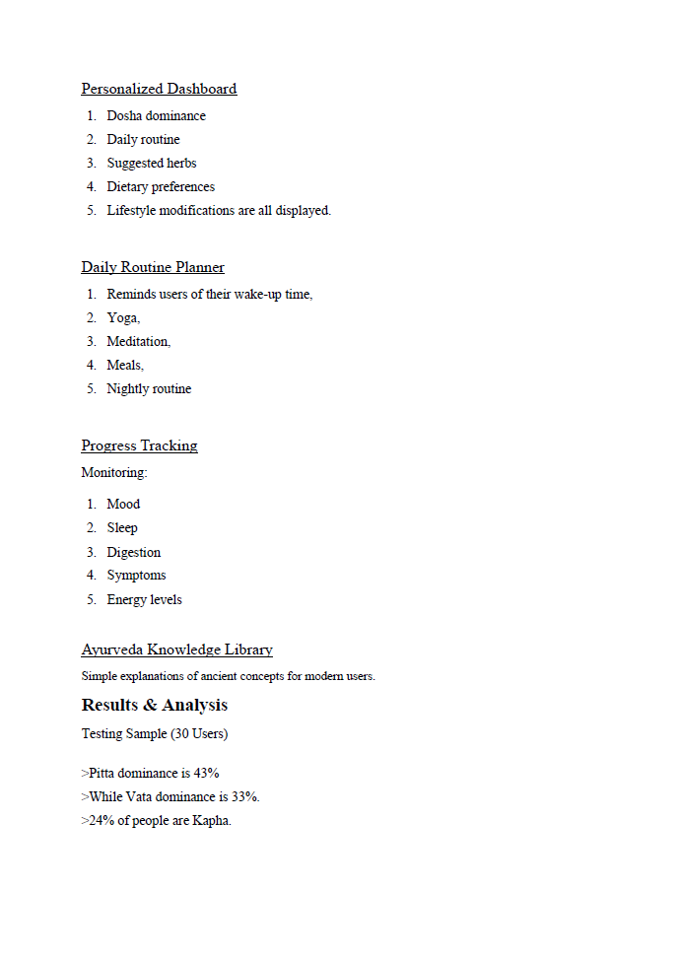

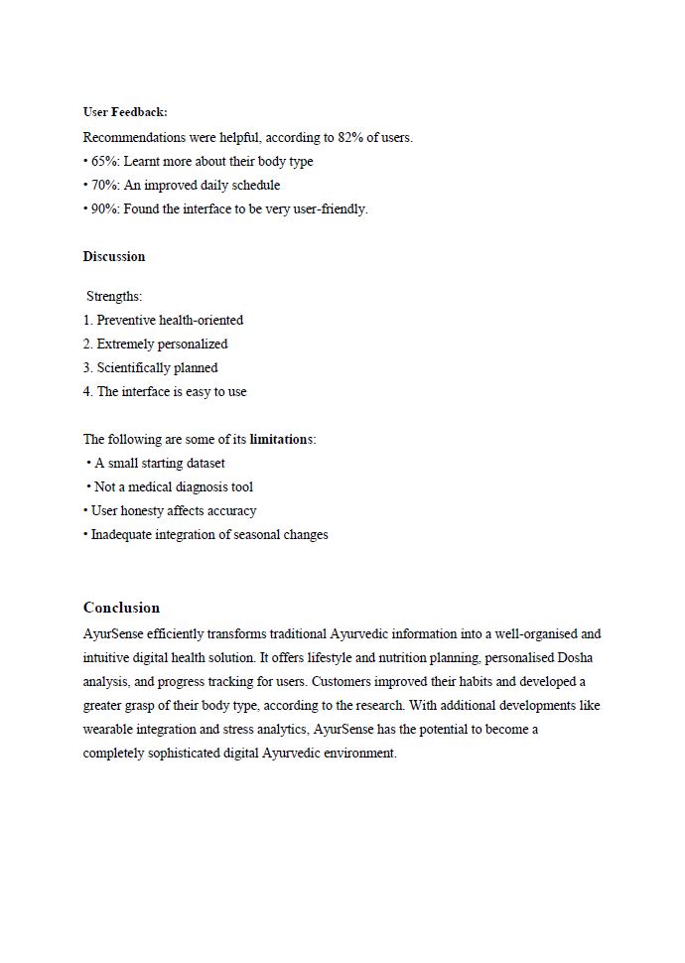


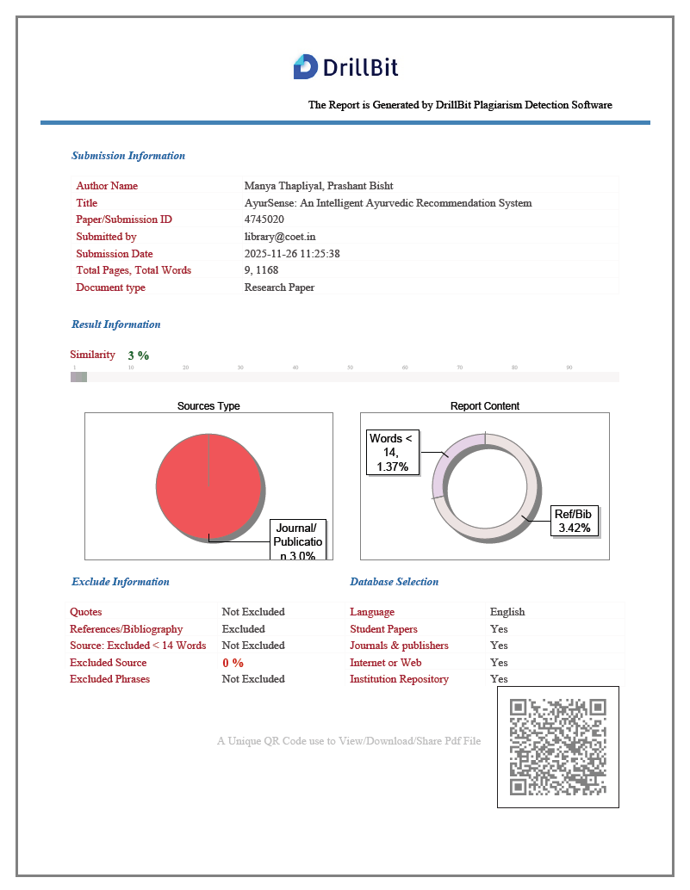
S

